

*802-Go:*

*Barangay 802 Management System*

Project Documentation Submitted to the Faculty of the

School of Computing and Information Technologies

Asia Pacific College

In Partial Fulfillment of the Requirements for

Introduction to Systems and Design for CS/IT

SSYADD1

By

|  |  |  |
| --- | --- | --- |
| Joana Grace Garcia | Allan Miguel Moldez | Hazel Ann Mones |

|  |  |
| --- | --- |
| Jhon Iberson Marinas | Jose Enrique Nunez |

2024

Table of Contents

Executive Summary iv

List of Figures v

List of Tables vi

I. Introduction 1

1. Project Context 1

2. Statement of the Problem 2

3. Objectives 2

4. Significance of the Project 3

5. Scope and Limitations 3

II. Review of Related Literature / Systems 5

III. Current Systems 9

3.1 Current System 9

3.2 Technical Background 9

3.3 List of Processes 10

3.4 Gap Analysis, Fishbone Diagram, and SWOT Analysis 11

IV. Proposed Solution 13

4.2 Lean Canvas 13

4.3 Product Vision 17

4.4 Technology Specifications 18

4.5 Feasibility 20

V. Requirement Analysis 22

5.1 Product Backlog and User Stories 22

5.2 Use Case Diagram 24

5.3 Fully Dressed Use Cases 25

5.4 Data Flow Diagram 31

5.5 Test Cases 36

5.6 Activity Diagrams with Swim lanes 41

5.7 Database Design 47

5.8 User Classes and Characteristics 47

5.9 Initial Cloud Hosted Prototype 48

5.10 Updates of Contents in Project GitHub Repository 51

5.11 Prototype 52

VI. Conclusion 53

References 54

Appendices 55

Appendix A: Project Vision 55

Appendix B: Schedule 56

Appendix C: Release Plan 57

Appendix D: Product Roadmap 59

Appendix E: Teams Meetings 60

# Executive Summary

The 802-Go project aims to modernize the outdated communication and service delivery systems of Barangay 802 in Santa Ana, Manila, by creating a centralized digital platform to improve community engagement and satisfaction. The project seeks to enhance communication between officials and residents, simplify the permit and license application process, and increase community involvement through interactive tools.

Supported by the Barangay Council and Sangguniang Kabataan (SK), 802-Go will feature online applications, and information system. It targets residents, local businesses, community organizations, and barangay officials. The project involves transitioning to digital records, developing a user-friendly portal, and providing technology training sessions.

Expected outcomes include improved record-keeping accuracy, modernized communication methods, streamlined service access, better resource management, and increased resident satisfaction. The project will foster a well-informed and engaged community, offering learning opportunities in digital transformation and community engagement. The next steps involve securing funding, finalizing project plans, and initiating development phases. Continuous support from key stakeholders—Barangay Council, SK, local businesses, community organizations, and residents—is crucial for success and sustainability, with regular updates and feedback loops ensuring the platform evolves to meet community needs.

# List of Figures

Figure 1. House-to-House Visits for Communication 10

Figure 2. Public Address System Announcements 10

Figure 3. Document and Permit Requests 10

Figure 4. Digital Encoding using Microsoft Word 11

Figure 5. Data Management in Microsoft Excel 11

Figure 6. Community Feedback and Reports………………………………………………………..11

Figure 7. Fishbone Diagram 12

Figure 8. SWOT Analysis 12

Figure 9. Use Case Diagram 24

Figure 10. Data Flow Diagram Level 0………………………………………………………………..31  
Figure 11. Data Flow Diagram Level 1………………………………………………………………..32  
Figure 12. Data Flow Diagram Level 2 Process 1…………………………………………………...33  
Figure 13. Data Flow Diagram Level 2 Process 2…………………………………………………...33  
Figure 14. Data Flow Diagram Level 2 Process 3…………………………………………………...34  
Figure 15. Data Flow Diagram Level 2 Process 4…………………………………………………...34  
Figure 16. Data Flow Diagram Level 2 Process 5…………………………………………………...35  
Figure 17. Data Flow Diagram Level 2 Process 6…………………………………………………...35  
Figure 18. Activity Diagram - Manage Account………………………………………………………41  
Figure 19. Activity Diagram - Document Request…………………………………………………...42  
Figure 20. Activity Diagram - View News/Announcements…………………………………………43  
Figure 21. Activity Diagram - Manage Resident Database…………………………………………44  
Figure 22. Activity Diagram - Manage Document Request…………………………………………45  
Figure 23. Activity Diagram - Manage News/Announcements……………………………………..46  
Figure 24. Entity Relationship Diagram……………………………………………………………….47  
Figure 25. Home Page Prototype……………………………………………………………………..49  
Figure 26. Log In Page Prototype……………………………………………………………………..50  
Figure 27. Register Page Prototype…………………………………………………………………..50  
Figure 28. GitHub Repository Commits………………………………………………………………51  
Figure 29. 802-Go Schedule Plan…………………………………………………………………….56

# List of Tables

Table I. List of Processes in the Current System 10

Table II. Gap Analysis 11

Table III. Product Backlog and User Stories 22

Table IV. User Classes and Characteristics 48

Table V. Project Vision 55

Table VI. Product Roadmap 59

Table VII. Minutes of the Meetings 60

# Introduction

Outdated communication methods often leave residents from different barangays in the Philippines struggling to stay informed about local events, services, rules, and announcements, resulting in a lack of awareness and low participation in community activities. Additionally, accessing barangay services can be inconvenient and inefficient, marked by long waits and bureaucratic delays. Communities also encounter difficulties in document requests and utilizing essential services such as computer and printing amenities, collectively leading to low resident satisfaction, and weakened community spirit.

The introduction of a centralized digital platform, such as 802-Go, aims to revolutionize community engagement and service delivery in various barangays. This initiative intends to modernize communication methods, streamline access to barangay services, and enhance resident satisfaction. Such a portal would facilitate active participation by incorporating features like surveys, community feedback and reports, thereby strengthening the sense of community, and providing valuable feedback for local authorities. Moreover, promoting technological adoption and digital literacy ensures residents can effectively utilize modern tools and engage with local government services independently.

Beyond addressing immediate challenges, the 802-Go concept aspires to contribute to the long-term development of communities. By improving resource management and utilization, this project ensures better management and access for residents. A well-informed, engaged, and satisfied community is more likely to thrive and support sustainable development efforts. The success of such projects can serve as a model for other barangays, demonstrating the benefits of a centralized digital platform and inspiring similar initiatives elsewhere, ultimately setting a precedent for future digital governance initiatives.

## Project Context

Barangay 802 in Santa Ana, Manila City, is a vibrant community facing challenges that hinder its growth and engagement. Outdated communication methods make it difficult for residents to stay informed about local events, services, rules, and announcements, leading to low participation in community activities. Accessing government services is often inconvenient and inefficient due to long waits and bureaucratic delays. Additionally, requesting documents and utilizing services such as computer and printing amenities are cumbersome and poorly managed, diminishing residents' satisfaction with local government services.

To address these issues, the team proposed the development of a Barangay Portal, named 802-Go—a one-stop website designed to transform how residents access information, services, and participate in local initiatives. This project aims to create a centralized digital platform to streamline communication, enhance service delivery, and foster greater community engagement. With the support of the Barangay Council and the Sangguniang Kabataan (SK), and under the guidance of SK Chairman Ms. Samantha Marie Eusebio, we aim to empower residents, ensuring they are well-informed, efficiently served, and actively involved in their community's development.

The Barangay Portal project seeks to address current challenges and pave the way for a more connected and cohesive community, transforming Barangay 802 into a model of modern community governance and participation.

## Statement of the Problem

Barangay 802 in Santa Ana, Manila City, faces several challenges that hinder its development:

1. **Outdated and Inefficient Record-Keeping.** The barangay relies on manual data maintenance using MS Excel, leading to errors, inefficiencies, and complications in data retrieval and management.
2. **Inefficient Access and Provision of Barangay Services.** The current system creates difficulties for barangay officials in efficiently providing services, resulting in prolonged waits, bureaucratic delays, and underutilization of resources.
3. **Outdated and Limited Communication Methods.** The barangay uses outdated communication channels, hindering effective dissemination of information to residents.
4. **Lack of Engagement with Residents.** The barangay experiences a lack of engagement between officials and residents, which impacts community involvement and communication effectiveness.

## Objectives

The Barangay Portal project aims to develop a centralized Barangay Management System for Barangay 802, Santa Ana, Manila City, integrating various solutions to streamline operations and improve service delivery. Specific objectives include:

1. **Transition to a Digital Record-Keeping System.** Improve efficiency, accuracy, and reliability in record-keeping by transitioning from manual data maintenance to a digital system.
2. **Develop an Efficient Barangay Services.** Enhance the management and utilization of barangay services through a centralized system to reduce waits and bureaucratic delays.
3. **Create a Centralized Information Hub.** Modernize communication by ensuring residents receive timely updates about community events, services, rules, and announcements through the digital platform.
4. **Enhance Community Engagement Tools.** Encourage active resident participation in community affairs by incorporating features like surveys, community feedback and reports.

## Significance of the Project

The Barangay Portal project is a pivotal initiative designed to enhance community engagement, streamline service delivery, and promote sustainable development within Barangay 802, Santa Ana, Manila City. The significance of this project is underscored by its comprehensive approach to addressing the needs of various customer segments, including residents, businesses, community organizations, and barangay officials.

1. **Barangay Officials and Staff.** For barangay officials, employees, and staff members, the Barangay Portal offers a powerful tool for managing administrative tasks and improving communication with residents. The digital platform streamlines service delivery, reducing administrative burdens and improving efficiency. By providing a user-friendly interface for processing documents, the portal enhances the operational efficiency of the barangay government. This efficiency translates to faster service delivery and increased resident satisfaction.
2. **Residents of the Barangay**. The primary beneficiaries of the Barangay Portal are the residents of Barangay 802. This project provides a centralized digital platform that significantly improves access to community information and government services. Residents will benefit from timely updates on local events, rules, and announcements, which fosters a more informed and engaged community. Additionally, the portal's interactive features, such as surveys, community feedback and reports, encourage active participation and feedback, enhancing the overall sense of community and involvement in local governance.
3. **Businesses and Entrepreneurs.** Local businesses, entrepreneurs, and startups operating within Barangay 802 will find the Barangay Portal indispensable for accessing vital information on business permits, licenses, and regulations. By simplifying these bureaucratic processes through an online platform, the project supports economic development and fosters a business-friendly environment. Entrepreneurs can efficiently navigate administrative requirements, allowing them to focus on growing their businesses and contributing to the local economy.
4. **Community Organizations and NGOs.** Non-governmental organizations (NGOs), community groups, and civic organizations are crucial stakeholders in the Barangay Portal project. These entities can use the portal to disseminate information, coordinate activities, and collaborate on community projects. The centralized platform facilitates better communication and partnership among various organizations, enhancing their ability to serve the community effectively. This collaboration can lead to more cohesive and impactful community development initiatives.

## Scope and Limitations

The Barangay Portal project's scope includes developing a comprehensive, user-friendly portal for Barangay 802, integrating digital services for permits, licenses, and . Additionally, the project will implement interactive tools to enhance community engagement and establish key performance metrics to monitor and evaluate the portal's effectiveness.

However, the project faces several limitations. Technological limitations may affect the portal's effectiveness, as residents' access to and familiarity with digital technology can vary. While efforts will be made to provide support and training, some residents may still encounter challenges. Resource constraints, including funding and technical expertise, could also limit the project's scope. Continuous support from local government and stakeholders is crucial to overcome these constraints. The success of the portal depends on the community's willingness to adopt and utilize the new system, and resistance to change or initial reluctance might slow down the adoption process. Furthermore, ensuring the portal remains up-to-date and operational requires ongoing maintenance and periodic updates, which necessitates a commitment from the barangay council and technical team.

# Review of Related Literature / Systems

**Assessment of Digital Information Systems for Local Barangays**

The paper "Assessment of Digital Information Systems for Local Barangays” [1] offers a thorough evaluation of a digital information system designed specifically for barangay administration. This system provides an online platform for managing and accessing information essential to local governance, public services, and community engagement, with the aim of improving transparency, accountability, and communication within barangay communities. The assessment examines the system's effectiveness, usability, and impact on various governance aspects, highlighting its advantages and limitations for policymakers and stakeholders.

This evaluation emphasizes the increasing importance of digital information systems in modernizing local governance, particularly in barangays, the smallest administrative units in the Philippines. By digitizing information and services, these systems have the potential to transform decision-making processes, enhance service delivery, and encourage community participation. The study's findings offer valuable insights into the challenges, benefits, and areas for improvement in implementing such systems, thus informing evidence-based policymaking and efforts to optimize these systems.

The assessment of digital information systems for local barangays closely aligns with the objectives and scope of our Barangay Portal project. Both initiatives recognize the critical role of technology in improving governance processes and community engagement at the grassroots level. While the evaluated system focuses on providing an online platform for information management and service delivery, our project aims to develop a user-friendly portal tailored to the specific needs and context of our barangay. By incorporating the evaluation’s emphasis on usability, functionality, and maintainability, we can refine our project's design and features to ensure seamless integration into barangay administration practices. Additionally, the insights gained from the assessment guide our approach to addressing technical challenges, promoting digital literacy, and maximizing the system's impact on transparency and accountability. Ultimately, this synthesis underscores the collaborative efforts and shared goals driving the development of digital information systems for effective local governance and community development.

**Barangay Management Information System (BAMIS)**

The evolution of e-governance systems has increasingly focused on leveraging technology to enhance local leadership and administrative efficiency. The Barangay Management Information System (BAMIS)[2] is a prime example of this shift, providing a comprehensive, data-driven solution for local governance in the Philippines. By facilitating improved data management and community services, BAMIS aims to transform local leadership from the Barangay to Local Government Units (LGUs).

The current studies on e-governance highlight the need for efficient information systems that can simplify administrative processes and improve service delivery. For example, robust information systems such as BAMIS have been shown to have notable results by promoting transparency, improving resource management, and fostering citizen participation. The introduction of BAMIS 2.0, with features such as offline and online system options, optimized database structures, and advanced analytics, aligns with best practices in e-governance by providing flexible, user-friendly solutions. Additionally, the focus on data security and comprehensive resident profiling addresses critical challenges in local governance.

This system has a direct relation to our project, Barangay Portal since it involves local governance, data management, community services, and the development of information systems for local leadership. The features and services offered by BAMIS, such as data backups and security, resident profiling, business establishment profiling, and ready-to-print certificates, can be relevant in the development of our project Barangay Portal, focused on improving local governance and community services. This literature highlights BAMIS as a relevant and supportive system that can inform and enhance the implementation of barangay-level e-governance projects like the e-barangay framework.

**Development of an Information-Based Dashboard: Barangay Resident Information System and Services (BRISS) for Decision Support towards e-Governance**

The paper titled "Development of an Information-Based Dashboard: Barangay Resident Information System and Services (BRISS) for Decision Support towards e-Governance"[3] introduces a system designed to enhance governance at the barangay level through information technology. BRISS aims to profile households in the community and provide essential statistics for decision-making by barangay officials, utilizing ICT to aggregate data on various aspects such as labor, income, demography, water, sanitation, housing, and education.

BRISS represents a significant step towards modernizing barangay administration by leveraging digital solutions to address manual processes and inefficiencies. Through its focus on data-driven decision-making and user-friendly interfaces, the system aims to empower barangay officials with the necessary tools to allocate resources effectively and respond to the needs of their constituents in a timely manner.

The BRISS system shares a common goal with our Barangay Portal project of leveraging information technology to improve local governance and service delivery. Both projects aim to address the challenges of manual processes and inefficiencies in barangay administration through digital solutions. While BRISS focuses on household profiling and decision support for barangay officials, our project aims to enhance record management, service accessibility, and community engagement. By drawing insights from the development methodology and features of BRISS, our project can better tailor its approach to meet the specific needs and context of our barangay community.

**E-Barangay: A Framework for a Web-Based System for Local Communities and Its Usability**

Barangay-level e-governance has gained increasing attention due to its potential to enhance loyal service delivery and citizen engagement.[4] Despite its importance, existing frameworks are focused towards governing on a higher level of state (municipal or national levels), leaving a significant gap in addressing the specific needs of barangay community. This gap leaves an opening for us to discuss the necessity for a dedicated framework tailored to the unique requirements of barangay-based governance.

Prior research on web-based frameworks on a barangay-level, the majority highlighted the effectiveness of digital platforms in improving government transparency, efficiency, and citizen participation. The study has shown that e-government initiatives at higher administrative levels often fail to account for the localized needs and contexts of smaller communities. Furthermore, usability and user-centered design have been identified as critical factors in the successful adoption of e-governance systems, as they directly impact user satisfaction and engagement. Despite these insights, the lack of a structured approach for implementing e-governance at the community level persists.

This study helped us to address and identify the gap in our project Barangay Portal, by providing a structured approach to barangay-level e-governance. By focusing on the core elements such as filing complaints, requesting documents, sending suggestions, and posting announcements, the framework ensures that the system is closely aligned with the needs of local citizens of Barangay 802. Good usability results, seen in both hard data and user views, and a strong link between design and use, prove the e-barangay framework is useful and needed. This literature supports the Barangay Portal’s goal of enhancing community engagement and service delivery through a tailored e-governance platform, demonstrating its potential for broader application and impact in similar contexts.

**E-Government in Digital Era: Concept, Practice, and Development**

E-Government refers to the use of information and communication technologies (ICTs) by government agencies to enhance access to and the delivery of information and services to citizens, businesses, and other stakeholders. This approach is gaining popularity in developing countries as governments increasingly recognize its potential benefits. E-Government initiatives aim to improve service efficiency and quality, boost transparency, and reduce administrative costs. Furthermore, these initiatives encourage greater citizen engagement in governance, fostering a more inclusive and participatory political environment.

However, implementing e-government in developing countries faces several challenges, such as the digital divide, which creates unequal access to services, and security and privacy concerns due to limited resources and expertise. Additionally, administrative, and political hurdles, including bureaucratic resistance and the need for strong political commitment, can impede progress. Despite these obstacles, e-government offers significant advantages: it enhances service delivery by streamlining processes, increases transparency and reduces corruption through open access to government data, and leads to cost savings via automation and reduced overhead expenses.

In his paper "E-Government in Digital Era: Concept, Practice, and Development," Zhiyuan Fang underscores the transformative potential of digital technologies in improving government service delivery and citizen engagement. Fang advocates for comprehensive e-government portals that provide convenient access to information and streamlined administrative processes, featuring 24/7 access and interactive platforms for citizen participation. Our proposed solutions—centralized information hubs, integrated digital platforms, and community engagement tools—align with these principles, addressing residents' difficulties in accessing information and services and fostering greater community involvement.

**Towards the Development of E-Barangay Mobile Application**

The paper discusses the role of barangays, which are the basic units of government in the Philippines.[6] Each barangay is governed by a chairman and other local officials who are responsible for maintaining peace, issuing business permits, and disseminating information. The study aims to explore the development of a mobile application called E-Barangay to enhance the services provided by these local government units (LGUs). The application is intended to handle residents' complaints, disseminate information, expedite the processing of government documents, and support decision-making processes.

The study reveals that residents have access to technology and are knowledgeable about using computers and the internet, which supports the feasibility of deploying a mobile application. However, participation in local community programs is lower, and information dissemination strategies by local officials need improvement. The application should address these issues by making services more accessible and efficient. Interviews with local officials highlighted the need for timely information dissemination and efficient handling of complaints and document requests. The E-Barangay application is designed to meet these needs by incorporating features such as complaint analysis, document request processing, and suggestion analysis.

The development of a barangay portal/website aligns with the findings from Bringula et al.'s study on the E-barangay mobile application, which highlights the need for a centralized information hub, streamlined government services, and enhanced community engagement. Our website will similarly centralize community information, facilitate online applications for permits and facility bookings, and incorporate interactive tools for resident participation. By integrating these features, we aim to improve information access, reduce bureaucratic hurdles, and foster greater community involvement, addressing the key issues identified in both studies.

# Current Systems

## 3.1 Current System

Upon the team's initial ocular visit to Barangay 802 in Santa Ana, Manila, we met with Ms. Samantha Maria Eusebio, the SK Chairman of the Barangay, who provided us with an overview of their current systems and processes. The barangay predominantly relies on manual operations, utilizing logbooks and printed physical copies for maintaining constituents' data. Additionally, they use Microsoft software, particularly Excel, to manage some of their records.

Communication with constituents is conducted primarily through direct methods. House-to-house visits are a widespread practice, and the barangay employs a public address system installed throughout the area to broadcast announcements, reminders, and other essential information. Meetings with residents are conducted in person, reinforcing a traditional approach to community engagement. Additionally, for document and permit requests, residents are required to visit the barangay office in person to submit their applications. This manual process applies to all types of document requests, adding to the foot traffic and workload at the barangay office.

Overall, the system in place is heavily dependent on physical presence and manual record-keeping, which poses challenges in terms of efficiency and convenience for both the barangay staff and the constituents.

## 3.2 Technical Background

The team had the opportunity to observe and closely examine the technologies used by Barangay 802. The barangay is equipped with at least one working computer, all with processors of Intel i5 or higher. They have a reliable internet connection that meets current speed standards, ensuring smooth online operations. Additionally, the barangay office is equipped with a printer, a Xerox copy machine, and two televisions that display the live feed from the barangay security system.

According to the Barangay Secretary, who is primarily responsible for digital encoding at the barangay, Microsoft Excel is the main tool used for encoding residents' data. For creating documents, permits, and other necessary paperwork, they rely on Microsoft Word. This setup highlights the barangay's utilization of both hardware and software to manage their administrative tasks, although it remains somewhat traditional with a focus on manual data entry and physical documentation.

So far, this is what the team has gathered regarding the technical background of the barangay. They demonstrate a basic yet functional use of technology, balancing between manual and digital systems to handle their daily operations.

## 3.3 List of Processes

Table I. List of Processes in the Current System

|  |  |  |  |
| --- | --- | --- | --- |
| **Process ID** | **Process Name** | **Process Details** | |
| **P001** | House-to-house Visits for Communication | Fig. 1 |
| **P002** | Public Address System Announcements | Fig. 2 |
| **P003** | Document and Permit Requests | Fig. 3 |
| **P004** | Digital Encoding using Microsoft Word | Fig. 4 |
| **P005** | Data Management in Microsoft Excel | Fig. 5 |
| **P006** | Community Feedback and Reports | Fig. 6 |

This table shows the current system of processes within Barangay 802, highlighting areas where the new digital platform, 802-Go, can improve efficiency, accessibility, and community engagement.

Barangay staff prepares the announcement or message.

Staff plans the route for house visits.

Staff visits each house to deliver the message.

Staff collects feedback from residents.

Fig. 1. House-to-House Visits for Communication

Barangay staff drafts the announcement.

Staff schedules the time for the announcement.

Announcement is broadcasted via the public address system.

Staff addresses any follow-up questions or concerns from residents.

Fig. 2. Public Address System Announcements

Resident visits the barangay office.

Resident submits a document or permit request.

Staff verifies the request details.

Staff processes the request in the computer.

Fig. 3. Document and Permit Requests

Resident is asked to pick up the completed document or permit.

Barangay Staff drafts the required document or permit in Microsoft Word.

Document is reviewed and edited for accuracy.

Document is approved by relevant authorities.

Document is finalized and printed.

Fig. 4. Digital Encoding using Microsoft Word

Barangay Staff manually distributes and collects biodata forms to and from residents.

Secretary enters data into Microsoft Excel.

Secretary verifies data accuracy.

Data file is saved and backed up in the Barangay Computer.

Staff generates reports as needed.

Fig. 5. Data Management in Microsoft Excel

Resident goes to the Barangay to submit feedback or report.

Secretary records the feedback or reports in a logbook.

Secretary escalates the feedback or report to the Chairman.

The Chairman takes the rightful action regarding the report.

Fig. 6. Community Feedback and Reports

## 3.4 Gap Analysis, Fishbone Diagram, and SWOT Analysis

Table II. Gap Analysis

|  |  |  |
| --- | --- | --- |
| **Current State** | **Desired State** | **Impact** |
| P001 | Implement digital communication channels | Saves time, reduces travel costs, enhances communication speed and record keeping |
| P002 | Use digital platforms for announcements | Broader reach, immediate updates, easy access to information |
| P003 | Online portal for document and permit requests | Faster processing, easy tracking, reduced paperwork |
| P004 | Streamlined digital encoding process (integrated system) | Consistent data format, reduces manual data entry errors |
| P005 | Advanced data management system (e.g., database software) | Enhanced data analysis capabilities, better data security, efficient data handling |
| P006 | Digital platform for submission, automated tracking, and real-time updates for both the Secretary and Chairman. | Faster submission, improved tracking, quicker responses, and better transparency for residents. |

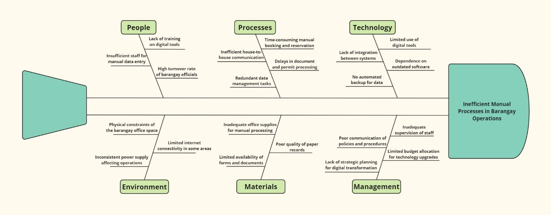

Fig. 7. Fishbone Diagram

Fig. 8. SWOT Analysis

# Proposed Solution

## 4.2 Lean Canvas

This Lean Canvas for the Barangay 802 Portal outlines a strategic blueprint designed to tackle the pressing challenges faced by Barangay 802 in Santa Ana, Manila City. It serves as a comprehensive plan to revolutionize the way our barangay operates, engages with residents, and delivers essential services. By harnessing modern technology, we aim to foster a more connected, efficient, and participative community. Here is an overview of what this lean canvas includes:

**4.2.1** **Problems**

In addressing the challenges faced by Barangay 802, we have identified several key issues that impact their ability to effectively serve and engage with their residents.

1. **Outdated Record-Keeping.** Manual data management using MS Excel leads to outdated and inefficient records, causing errors and complications.
2. **Outdated Communication.** The barangay relies on old communication methods, making it difficult to share information effectively.
3. **Inefficient Service Access and Provision.** The barangay and residents encounter challenges in providing and accessing services efficiently, resulting in extended waits, delays, and frustration.
4. **Lack of Resident Engagement:** There is limited interaction between the barangay and residents, indicating a need for better communication and involvement systems.

**4.2.2** **Solutions**

To enhance the barangay's service delivery and community engagement, we propose the following solutions designed to address the identified challenges effectively.

1. **Implement a Digital Record-Keeping System.** Transition from manual data maintenance using MS Excel to a comprehensive digital record-keeping system. This system will feature:
2. **Centralized Database Management.** A secure, cloud-based database for real-time updates and easy information retrieval.
3. **Automated Data Entry and Validation.** Forms with validation checks to reduce human errors.
4. **Data Backup and Recovery.** Regular automated backups and a robust data recovery plan.
5. **Data Analytics and Reporting Tools:** Tools to generate insightful reports and analytics for better decision-making.
6. **Implement an Integrated Online Platform.** Develop an online platform that allows residents to apply for documents, submit feedback and reports, accessible 24/7. This platform will streamline bureaucratic processes and facilitate the scheduling of barangay facilities such as the basketball court and computer/printing services.
7. **Establish a Centralized Information Hub** Create a user-friendly website for the barangay that serves as a centralized hub for all community-related information. This website will include event calendars, government announcements, service directories, and regulatory updates, ensuring residents have easy access to the latest information.
8. **Utilize Community Engagement Tools.** Develop interactive features like polls, surveys, and discussion boards to help barangay administrators gather feedback from residents, encourage engagement, and foster a sense of community ownership and participation.

**4.2.3** **Key Metrics**

In order to effectively measure the success and impact of the barangay portal, we have outlined key metrics across three categories:

1. **User Engagement Metrics**

* **Number of active users.** Measure the total number of users who actively engage with the portal over a specific period.
* **User session duration.** Track the average time users spend on the portal per session, indicating the level of engagement and interest.
* **Page views and unique visitors.** Monitor the total number of pages viewed and unique visitors to assess overall portal traffic and popularity.

1. **Document Request Metrics**

* **Number of document requests.** Track the total number of requests made through the online document request system to gauge its usage and demand.
* **Processing time.** Measure the average time taken to process document requests from submission to completion, ensuring efficiency and timeliness.

1. **Customer Satisfaction Metrics**

* **User feedback and ratings.** Gather feedback from users through surveys, ratings, and reviews to assess satisfaction levels and identify areas for improvement.

**4.2.4** **Unique Value Propositions**

In our commitment to modernize and optimize the services provided by our barangay administration, we present the unique value propositions of the Barangay Portal, designed to enhance connectivity, streamline administrative processes, and foster community engagement.

1. **Streamlined Administrative Processes**. With our integrated digital platform, The Barangay Portal streamlines administrative procedures, reducing queues and bureaucratic challenges. This enables swift processing of permits, and access to barangay services, enhancing operational efficiency for the barangay administration.
2. **Enhanced Connectivity and Information Accessibility.** The Barangay Portal serves as a centralized hub for all community-related information, facilitating seamless access to event calendars, government announcements, and important updates for efficient governance and decision-making.
3. **Facilitated Community Engagement and Feedback.** The Barangay Portal empowers the barangay administration to foster community participation and gather valuable feedback. Through interactive engagement tools, residents can actively contribute to shaping the future of the barangay, ensuring inclusive governance and representation of diverse voices.

**4.2.5** **Customer Segments**

The customer segments for the Barangay Portal encompass a diverse range of users, each with unique needs and objectives, including residents, businesses, community organizations, and barangay officials.

1. **Barangay Officials and Staff.** Barangay officials, employees, and staff members are the primary target users of the portal. They may use the portal for administrative tasks, communication with residents, and managing government services and initiatives.
2. **Residents of the Barangay.** The target customer segment includes all residents living within the Barangay. This segment seeks access to community information, government services, and opportunities for engagement and participation in local initiatives.
3. **Businesses and Entrepreneurs.** This segment comprises local businesses, entrepreneurs, and startups operating within the Barangay. They may use the Barangay Portal to access information on business permits, licenses, regulations, and economic development opportunities.
4. **Community Organizations and NGOs.** Non-governmental organizations (NGOs), community groups, and civic organizations working within the Barangay are another target segment. They may utilize the Barangay Portal to disseminate information, coordinate activities, and collaborate on community projects.

**4.2.6** **Channels**

The channels for promoting and utilizing the Barangay Portal include a variety of methods to ensure comprehensive outreach and engagement:

1. **Website.** The Barangay Portal's official website serves as the primary channel for residents to access information, request documents, and engage with community tools and features.
2. **Social Media Platforms.** Utilize existing social media accounts and pages on platforms such as Facebook, Twitter, and Instagram of Barangay Officials to promote the Barangay Portal, share updates, and interact with residents. These platforms can also be used to run targeted advertising campaigns to reach a wider audience.
3. **Community Events and Meetings.** Attend local community events, town hall meetings, and barangay assemblies to promote the Barangay Portal, gather feedback, and engage with residents face-to-face.
4. **Word of Mouth.** Encourage users to spread the word about the Barangay Portal to their friends, family, and neighbors, leveraging the power of word-of-mouth marketing within the community.

**4.2.7** **Revenue Streams**

The revenue streams for the Barangay Portal are designed to ensure financial sustainability while providing valuable services, including document processing fees, partnerships and collaborations, advertisement and sponsorship opportunities, and transaction fees.

1. **Document Processing Fees.** Charge residents and businesses a fee for processing document requests through the online document request system. This fee can cover administrative costs and generate revenue for the barangay.
2. **Partnerships and Collaborations.** Form partnerships with local businesses, service providers, and organizations to offer exclusive deals, discounts, and promotions to Barangay Portal users. Generate revenue through affiliate commissions or revenue-sharing agreements.
3. **Advertisement and Sponsorship.** Generate revenue through advertising opportunities on the Barangay Portal's website, newsletter, and social media channels. Partner with local businesses, and organizations to sponsor content or events on the portal.
4. **Transaction Fees.** Collect a small percentage of transaction fees for online payments processed through the portal, such as permit fees, license renewals, event registrations, and donations.

**4.2.8** **Cost Structure**

The cost structure for the Barangay Portal encompasses both fixed and variable costs, ensuring a clear understanding of the financial investments required for development, maintenance, and operation.

1. **Fixed Costs**

* **Website Development and Maintenance.** This includes one-time costs for designing, developing, and launching the website, as well as ongoing expenses for hosting, domain registration, and maintenance.
* **One-time investment.** This includes the initial costs associated with designing, developing, and launching the website.
* **Recurring capital expense.** Ongoing expenses for hosting, domain registration, and maintenance.
* **Software Licensing and Subscription Fees.** Fixed costs associated with licensing fees for software platforms, tools, and services used to build and operate the Barangay Portal, such as content management systems, customer relationship management (CRM) software, and payment processing solutions.
* **One-time investment.** Some software licenses may involve a one-time purchase.
* **Recurring capital expense.** Subscription fees for software platforms, tools, and services used to build and operate the Barangay Portal, such as content management systems, customer relationship management (CRM) software, and payment processing solutions.

1. **Variable Costs**

* **Transaction Fees.** Variable costs associated with processing online payments for document requests and other services offered through the portal, including fees charged by payment gateways and financial institutions.
* **Recurring capital expense.** Variable costs associated with processing online payments for document requests and other services offered through the portal, including fees charged by payment gateways and financial institutions.
* **Server and Bandwidth Usage.** Variable costs associated with server usage and bandwidth consumption, which may fluctuate based on website traffic and user activity.
* **Recurring capital expense.** Variable costs associated with server usage and bandwidth consumption, which may fluctuate based on website traffic and user activity.

**4.2.9** **Unfair Advantage**

With direct collaboration from the barangay council and Sangguniang Kabataan, we have insider insights and support, ensuring our portal is tailor-made to meet the unique needs of the community. This combination of factors creates a strong competitive advantage for the Barangay Portal, making it difficult for other information channels to replicate its reach and impact within the barangay.

1. **Unique position as the official source of information and services for the barangay.** Residents trust the portal as a reliable and secure platform endorsed by the barangay council.
2. **Direct access to a captive audience.** The portal can reach all residents within the barangay, creating a valuable platform for communication and engagement.
3. **Community-specific focus.** The portal caters to the specific needs and interests of the barangay residents, offering localized information and services not readily available elsewhere.

## 4.3 Product Vision

In response to the pressing needs of residents, businesses, community organizations, and barangay officials of Barangay 802 in Santa Ana, Manila City, who struggle with outdated communication methods, inefficient service access, and low community engagement, the Barangay Portal emerges as a transformative solution.

**For:** TheBarangay officials, residents, businesses, and community organizations in Barangay 802 of Santa Ana, Manila City.

**Who:** Encounter challenges in providing and accessing services efficiently, contend with outdated communication methods, and struggle with limited resident engagement and participation.

**The:** 802-Go is a centralized digital platform.

**That:** Enhances service access and delivery, streamlines communication, and fosters community engagement.

**Unlike:** Conventional Barangay Systems.

**Our product:** Provides a user-friendly, one-stop website that empowers residents, supports local businesses, and facilitates efficient governance through modern technology.

## 4.4 Technology Specifications

The successful development and implementation of the 802-Go will require a comprehensive integration of various technologies, including hardware, software, peopleware, and network components. Below are the detailed specifications for each aspect:

**Hardware**

1. **Servers**:

* **Web Server**: A high-performance server capable of handling multiple concurrent user requests, hosting the website and database. Specifications include at least a multi-core processor (e.g., Intel Xeon), 16GB RAM, and SSD storage for fast data access.
* **Backup Server**: A secondary server for data backup and redundancy to ensure data integrity and availability in case of primary server failure.

1. **Client Workstations**:

* **Barangay Office Computers**: Upgrading existing i5 processor of at least one computer with additional RAM (at least 8GB) and SSDs for faster performance.
* **Peripheral Devices**: Ensuring availability of necessary peripherals like printers (both inkjet and laser), scanners, and photocopy machines.

1. **Network Equipment**:

* **Router and Switches**: Enterprise-grade router and switches to manage and optimize network traffic.

**Software**

1. **Content Management System (CMS)**:

* A robust CMS like WordPress or Drupal, allowing for easy content updates and management by barangay staff.

1. **Database Management System (DBMS)**:

* A relational database, specifically, MySQL for storing resident data, document requests, and other transactional data securely.

1. **Web Framework**:

* Use of modern web development frameworks, specifically, Laravel (PHP) to build a scalable and secure backend system.

1. **Front-end Technologies**:

* HTML5, CSS3, JavaScript, and frameworks like React or Angular for creating a responsive and user-friendly interface.

1. **Security Software**:

* Implementation of security protocols including SSL/TLS for data encryption, firewalls, and regular security audits.
* Antivirus and anti-malware software for client and server protection.

1. **Collaboration Tools**:

* Integration with tools like Slack or Microsoft Teams for internal communication among barangay staff.

**Network**

1. **Internet Connectivity**:

* High-speed broadband connection to support seamless access to the portal for both staff and residents.
* Redundant internet connections to ensure continuous availability.

1. **Intranet**:

* Establishing a secure intranet within the barangay office for internal communication and data sharing.

1. **Cloud Services**:

* Utilizing cloud services for data storage, backup, and scalability. Platforms like AWS, Google Cloud, or Microsoft Azure are considered for the project.

**Peopleware**

1. **Development Team**:
   * **Project Manager**: Overseeing project development, timelines, and resource allocation.
   * **Developer(s)**: Developers proficient in chosen web frameworks and technologies.
   * **Database Administrator(s)**: Managing the database, ensuring data integrity, security, and backups.
   * **UI/UX Designer(s)**: Designing intuitive and accessible interfaces for the portal.
   * **Quality Assurance**: Ensuring the system is bug-free and meets all requirements through rigorous testing.
2. **Barangay Staff**:
   * **Administrators**: Handling content updates, document requests, and resident interactions through the portal.
   * **IT Support**: Providing technical assistance to both staff and residents, maintaining hardware and software systems.
3. **Training and Support**:
   * Conducting training sessions for barangay staff and residents to familiarize them with the new system.
   * Providing ongoing technical support and helpdesk services.

By leveraging these technology specifications, the 802-Go project aims to create a robust, efficient, and user-friendly digital platform that will significantly enhance the governance and community engagement in Barangay 802.

## 4.5 Feasibility

**Operational Feasibility**

The operational feasibility of the Barangay Portal project is promising, given its alignment with the immediate needs and capabilities of Barangay 802. The existing basic yet functional use of technology within the barangay provides a solid foundation for the introduction of more advanced digital solutions. The current infrastructure, including a computer, internet connectivity, and peripheral devices like printers and copiers, supports the shift towards a centralized digital platform. Furthermore, the strong support from the Barangay Council and the Sangguniang Kabataan (SK) under the leadership of SK Chairman Samantha Marie Eusebio indicates a high level of commitment to operational changes. The project's goals of enhancing service delivery, improving communication, and fostering community engagement are well within the scope of the barangay's operational capabilities, making the transition to the 802-Go platform manageable and practical.

**Economic Feasibility**

From an economic standpoint, the Barangay Portal project is feasible due to its potential to generate multiple revenue streams while optimizing costs. Initial funding will cover website development, software licensing, and training for barangay staff. The project anticipates generating revenue through document processing fees, partnerships with local businesses, advertisement opportunities, and transaction fees for online payments. These income sources are expected to offset initial investments and ongoing operational costs. Moreover, the reduction in manual processes and administrative burdens will lead to cost savings in the long run. By streamlining service delivery and improving efficiency, the barangay can allocate resources more effectively, ensuring the project's sustainability and financial viability.

**Technical Feasibility**

The technical feasibility of the Barangay Portal project is robust, supported by the existing technological infrastructure in Barangay 802. The barangay is equipped with a computer featuring processors of i5 or higher, a reliable internet connection, and essential peripheral devices. The transition from manual data management to a digital system is feasible given this infrastructure. Additionally, the team plans to implement a cloud-based database for real-time updates and data management, ensuring security and accessibility. The use of established software for data entry, document creation, and communication will be enhanced by integrating these tools into a centralized, user-friendly platform.

**Schedule Feasibility**

The development and implementation of the Barangay Portal project are scheduled to align with the academic calendar of Asia Pacific College, spanning three terms in the Project-Based Learning (PBL) courses. This timeline ensures that the project receives continuous attention and resources, allowing for thorough development, testing, and refinement. The phased approach will include initial planning and design, followed by development, implementation, and evaluation phases. Regular assessments and feedback loops will ensure that the project stays on track and meets its milestones. This structured schedule supports the feasibility of delivering a functional and effective digital platform within the allotted time frame.

# V. Requirement Analysis

## 5.1 Product Backlog and User Stories

This product backlog includes user stories for different roles (Administrator, Member, Visitor) to ensure a comprehensive and user-focused approach to the development of the 802-Go digital portal. The priorities (Must, Should, Could) help in focusing on the most critical features first.

Table III. Product Backlog and User Stories

|  |  |  |  |  |
| --- | --- | --- | --- | --- |
| **ID** | **As a/an...** | **I want to be able to...** | **So that....** | **Priority** |
| **1** | Administrator | See a list of all residents | I can monitor and manage resident information | Must |
| **2** | Administrator | Add new categories of services | I can organize services efficiently for residents | Must |
| **3** | Administrator | Add new security groups | Security levels are appropriate for different users | Must |
| **4** | Administrator | Add new keywords for content | Content is easy to group and search for | Must |
| **5** | Administrator | Moderate offensive or unnecessary comments | Offensive or Unnecessary content is removed | Must |
| **6** | Administrator | Block entries that violate guidelines | Competitors and offenders cannot submit harmful content | Must |
| **7** | Administrator | Change site branding | The site reflects the current image and branding of Barangay 802 | Could |
| **8** | Administrator | Generate traffic reports | I can understand where traffic is coming from and improve services | Must |
| **9** | Administrator | Export traffic reports into PDF format | I can share traffic data with leadership for analysis | Must |
| **10** | Member | Change my password | I can keep my account secure | Must |
| **11** | Member | Update my contact and personal details | I can be contacted by barangay officials | Must |
| **12** | Member | Update my email preferences | I'm not bombarded with irrelevant emails | Must |
| **13** | Member | Share content to social networks | I can promote community events and information | Could |
| **14** | Member | Answer polls or surveys | I can participate in polls or surveys | Must |
| **15** | Member | Submit feedback or reports | I can submit feedback or reports | Must |
| **16** | Member | Contact the administrators | I can directly submit queries and concerns | Must |
| **17** | Member | View a member’s profile | I can know more about active community members | Should |
| **18** | Visitor | Follow updates from the barangay | I’m informed of important announcements and events | Must |
| **19** | Visitor | Create an account | I can benefit from member-only features | Must |
| **20** | Member | Login to the portal | I can access personalized content | Must |

## 5.2 Use Case Diagram

Fig. 1. Use Case Diagram

The use case diagram for the Barangay Management System illustrates interactions between members and administrators, supporting various functionalities like account management, service requests, content sharing, and feedback provision. This digital platform aligns with the objective of transitioning to a digital record-keeping system by allowing digital account and service management, thereby improving efficiency, accuracy, and reliability. Furthermore, the system modernizes communication by enabling members to access and share updates about community events, services, and announcements, creating a centralized information hub. Additionally, community engagement is promoted by allowing members to share feedback and suggestions, and submit reports, encouraging active participation in community affairs.

## 5.3 Fully Dressed Use Cases

The Fully Dressed Use Cases provide in-depth scenarios detailing specific interactions within the 802-Go platform, capturing both common and edge cases. These use cases outline the expected user actions and system responses to help ensure that the platform meets the community’s needs effectively. By focusing on detailed workflows, these use cases will support developers in implementing features that improve communication, streamline application processes, and enhance community involvement.

**Manage Account**

Table IV. Fully Dressed Use Case - Manage Account

|  |  |
| --- | --- |
| Use Case ID: | UC-001 |
| Use Case Name: | Manage Account |
| Created By: | Allan Miguel O. Moldez |
| Date Created: | September 21, 2024 |
| Description: | This use case allows residents and barangay officials to manage their user accounts. Users can choose to log in if they already have an account, or sign up if they do not have an existing account. Once logged in, users can update or delete their account, including updating their personal information and login credentials. |
| Primary Actor: | Residents |
| Secondary Actor: | Barangay Officials |
| Included use cases: | Account Management |
| Preconditions: | 1. The user must have access to the Barangay Management System. |
| Postconditions: | * If the user logs in, they are authenticated, and their account information is displayed. * If the user signs up, a new account is created and saved in the system. * The user's account information is successfully updated or deleted. * The system reflects the current account status and changes. |
| Main Flow: | The system presents two options: "Log in" or "Sign up."  **For existing users (Log in):**   1. The user selects the "Log in" option. 2. The system prompts the user for their credentials (username and password). 3. The system verifies the credentials. 4. If valid, the system displays the account management options (update profile, change password, delete account, etc.). 5. The user selects the desired action (e.g., update profile). 6. The user inputs the necessary changes (e.g., updating name, contact details). 7. The system validates the information entered. 8. The system saves the changes and displays a confirmation message.   **For new users (Sign up):**   1. The user selects the "Sign up" option. 2. The system prompts the user for their personal details (name, address, email, etc.) and creates a new account. 3. The user sets a password for the new account. 4. The system saves the new account details and logs the user in automatically. 5. The system displays the account management options for further customization (update profile, etc.). 6. The user can proceed to update the profile or use the system as desired. |
| Alternate Flow: | **AF1: Invalid login credentials**   1. If the login credentials are invalid, the system displays an error message. 2. The user is prompted to re-enter their credentials. 3. Once the user corrects their credentials after being prompted, the flow should return to the main sequence at Step 3, where the system verifies the credentials.   **AF2: Missing or invalid sign-up information.**   1. If the new user provides incomplete or invalid details during sign-up, the system displays an error message prompting the user to correct or complete the information. 2. The user is prompted to correct or complete the missing information before the account is created 3. After the user corrects the missing or invalid information, they should continue from Step 3 of the main flow, where the system saves the new account details and logs the user in automatically. |

**Request Document**

Table V. Fully Dressed Use Case - Request Document

|  |  |
| --- | --- |
| Use Case ID: | UC-003 |
| Use Case Name: | Request Document |
| Created By: | Joana Grace Garcia |
| Date Created: | September 21, 2024 |
| Description: | This use case allows residents to request official documents such as certificates or permits from the barangay office. The system enables users to select the type of document, input relevant details, and submit the request for processing by barangay officials. |
| Primary Actor: | Residents |
| Secondary Actor: | Barangay Officials |
| Included use cases: | Request Document |
| Preconditions: | * The user must be logged into the Barangay Management System. * The user must have the necessary permissions to request the document. * The barangay system must have predefined document types available for request. |
| Postconditions: | * The user's document request is successfully submitted and recorded in the system. * The barangay officials are notified of the request for further processing. * The system tracks the request status for the user to follow up. |
| Main Flow: | 1. The user selects the "Request Document" option from the main dashboard. 2. The system displays a list of available document types (e.g., Barangay Clearance, Certificate of Residency). 3. The user selects the type of document they wish to request. 4. The system prompts the user to input any required details (e.g., purpose of the request, personal information, supporting documents). 5. The user fills in the required details and submits the request. 6. The system validates the information. 7. The system confirms that the document request has been successfully submitted and provides a reference number for tracking. 8. The user logs out or continues to use the system. |
| Alternate Flow: | **AF1: Missing or incomplete information during document request.**   1. If the user submits the request with missing or incomplete information, the system displays an error message. 2. The user is prompted to complete the missing fields and re-submit the request. 3. After the user completes the missing fields, the flow should return to the main flow at Step 6, where the system validates the information.   **AF2: Document type unavailable.**   1. If the user tries to request an unavailable document, the system shows a message indicating the unavailability. 2. The user is provided with an option to be notified when the document type becomes available. 3. If the user opts to be notified about the document availability, the alternate flow might logically end, or the user can return to Step 3 to select a different document type once the unavailable one becomes accessible. |

**View News/Announcements**

Table VI. Fully Dressed Use Case – View News/Announcements

|  |  |
| --- | --- |
| Use Case ID: | UC-003 |
| Use Case Name: | View News/Announcements |
| Created By: | Hazel Ann Mones |
| Date Created: | September 21, 2024 |
| Description: | This use case allows residents and barangay officials to view the latest news and announcements posted by the barangay. The system will display a list of announcements, and users can view the details of each announcement. |
| Primary Actor: | Residents |
| Secondary Actor: | Barangay Officials |
| Included use cases: | View News/Announcements |
| Preconditions: | * The user must be logged into the Barangay Management System. * The system must have existing news and announcements to display. |
| Postconditions: | * The user views the list of available news and announcements. * The system tracks which announcements the user has viewed. |
| Main Flow: | 1. The system displays the Home Page, where the user will see the "News/Announcements." 2. The system displays a list of recent news and announcements. 3. The user selects an announcement to view the details. 4. The system displays the full details of the selected announcement. 5. The user reads the news/announcement and returns to the list or goes back to the main dashboard. |
| Alternate Flow: | **AF1: No news or announcements available.**   1. If no news or announcements are available, the system displays a message indicating that there are no current announcements to view. 2. The user can still see the history of news/announcements from the barangay 3. The user will now be on the step 5   **AF2: User logs out without viewing announcements.**   1. The user decides to log out before viewing any announcements. 2. The system logs the user out and returns to the login page without showing any announcements. |

**Manage Resident Database**

Table VII. Fully Dressed Use Case – Manage Resident Database

|  |  |
| --- | --- |
| Use Case ID: | UC-004 |
| Use Case Name: | Manage Resident Database |
| Created By: | Jhon Iberson Mariñas |
| Date Created: | September 21, 2024 |
| Description: | This use case describes how barangay officials can view and manage resident information stored in the barangay’s database. |
| Primary Actor: | Barangay Official |
| Secondary Actor: | Residents |
| Included use cases: | Manage Resident Database |
| Preconditions: | * Barangay official must be logged into the Barangay Management System. * Resident data must already exist in the system. |
| Postconditions: | * Barangay official can view detailed information about residents and take further actions if required. |
| Main Flow: | 1. Barangay Official navigates to the "Resident Database" section. 2. System displays a list of all registered residents. 3. Barangay Official selects a resident from the list to view their details. 4. System shows detailed information of the selected resident, including personal information and any history of requests or incidents. 5. Barangay Official either reviews the data for informational purposes, updates the information, or flags incorrect data for review. |
| Alternate Flow: | **AF1. No Residents Available:**   * If the system finds no resident data in the database, it will display a message: "No residents found in the database." * The barangay official can either attempt to search again or log out. The user will continue to step 4 of the main flow.   **AF2. Resident Information Needs Correction:**   * If the barangay official finds that resident data is incorrect, the system allows them to flag the information for review. * The official can submit the flagged data for further verification, and the resident is notified to update their information. * After the resident data is flagged for correction, the barangay official can return to Step 5 to review or update the data. |

**Manage Document Request**

Table VIII. Fully Dressed Use Case – Manage Document Request

|  |  |
| --- | --- |
| Use Case ID: | UC-005 |
| Use Case Name: | Manage Document Request |
| Created By: | Jose Enrique Nuñez |
| Date Created: | September 21, 2024 |
| Description: | This use case describes how barangay officials view and manage document requests submitted by residents through the Barangay Management System. |
| Primary Actor: | Barangay Official |
| Secondary Actor: | Residents |
| Included use cases: | Manage Document Request |
| Preconditions: | * Barangay official must be logged into the Barangay Management System. * Document requests must have been submitted by residents. |
| Postconditions: | * The barangay official has viewed the document requests and can either take further actions or leave them pending. |
| Main Flow: | 1. Barangay Official navigates to the "Document Requests" section. 2. System displays all document requests submitted by residents. 3. Barangay Official selects a request to view its details. 4. System shows detailed information of the selected document request, including the resident's details and the type of request. 5. Barangay Official either closes the request if no further action is required, or updates the status to "In Progress" or "Pending Approval" based on the review. 6. The Barangay official can either wait for new request or exit the system |
| Alternate Flow: | **AF1. No Document Requests Available:**   * If there are no document requests in the system, the system will display a message: "No pending document requests at this time." * The barangay official will return to the step 6 of the main flow   **AF2. Request Requires Additional Information:**   * If the barangay official finds that the request is incomplete, the system allows them to mark the request as "Incomplete." * The system sends a notification to the resident requesting additional information before processing continues. The barangay official is then returned to the step 5 of the main flow |

**Manage News/Announcements**

Table IX. Fully Dressed Use Case – Manage News/Announcements

|  |  |
| --- | --- |
| Use Case ID: | UC-006 |
| Use Case Name: | Manage News/Announcements |
| Created By: | SISTEM |
| Date Created: | September 21, 2024 |
| Description: | This use case describes how barangay officials can post news and announcements to the barangay website for residents to view. |
| Primary Actor: | Barangay Official |
| Secondary Actor: | Residents |
| Included use cases: | Manage News/Announcements |
| Preconditions: | * Barangay officials must be logged into the Barangay Management System. * The system must be connected to the website portal where announcements and news are posted. |
| Postconditions: | * The news or announcement is published and visible to all residents through the barangay portal. |
| Main Flow: | 1. Barangay Official navigates to the "News/Announcements Management" section. 2. Barangay Official selects either "Post News" or "Post Announcement." 3. System displays a content creation form for the barangay official to input the necessary information. 4. Barangay Official enters the news/announcement title, content, and any other required details. 5. Barangay Official submits the news/announcement for publishing. 6. System publishes the content to the barangay website, making it available for residents to view. 7. Residents receive a notification about the new news/announcement when they log into the barangay portal. |
| Alternate Flow: | **AF1. Invalid Input in Content Creation Form:**   * If the barangay official submits incomplete or invalid content (e.g., missing title or body), the system displays an error message: "Please complete all required fields." * The official must correct the errors before proceeding and will return to the step 5 of the main flow.   **AF2. Website Down for Maintenance:**   * Once the website is back online, the system should automatically publish the queued news or announcement, resuming from Step 6 where the content becomes visible to residents. |

## 5.4 Data Flow Diagram

The Data Flow Diagram (DFD) provides a structured overview of how information flows within the 802-Go system, from high-level interactions (Context Diagram) to more detailed processes (Level 1 and Level 2). This diagram highlights the sources and destinations of data, helping stakeholders understand how different components of the platform connect to support communication, record-keeping, and service delivery.

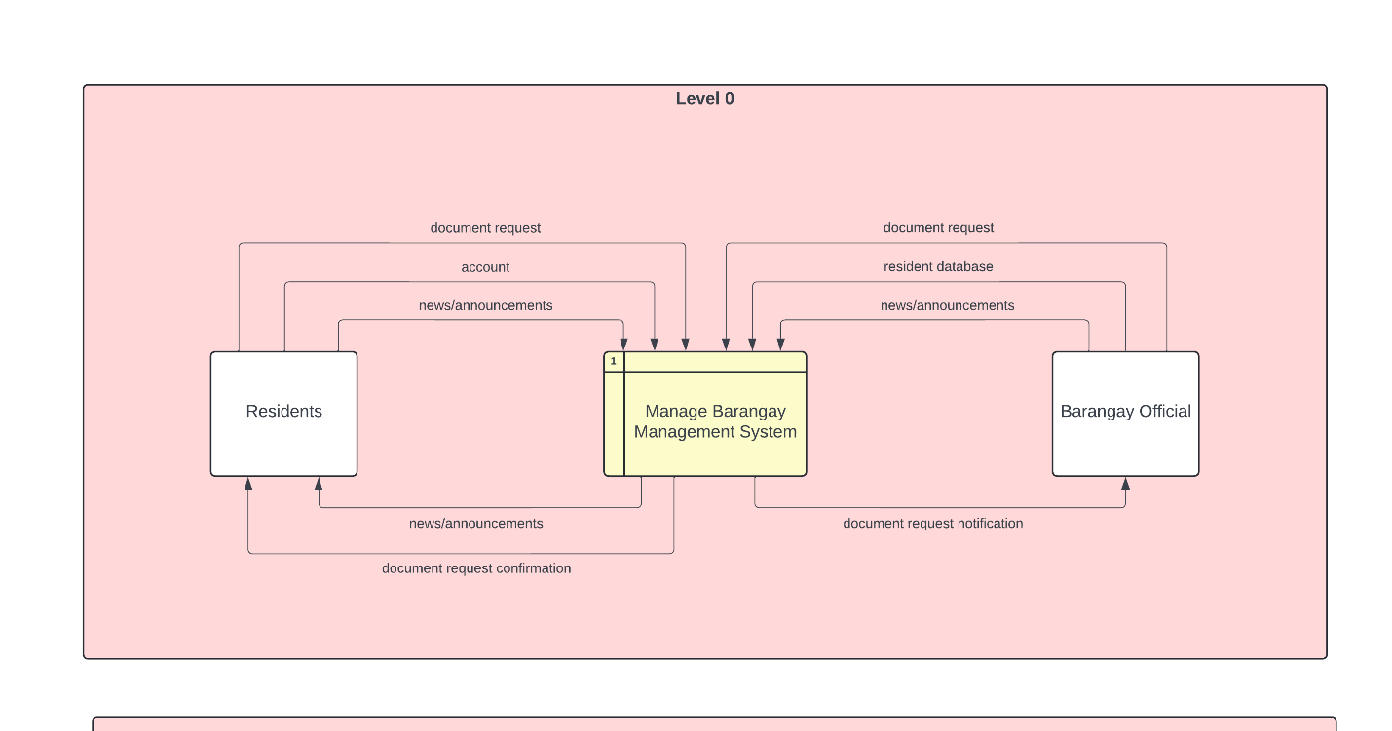

Fig. 10. Data Flow Diagram Level 0

The Level 0 Data Flow Diagram (DFD) illustrates the primary processes and data flows within the Barangay Management System for the 802-Go project. This high-level overview shows the interactions between the two main user groups—Residents and Barangay Officials—and the central Manage Barangay Management System.

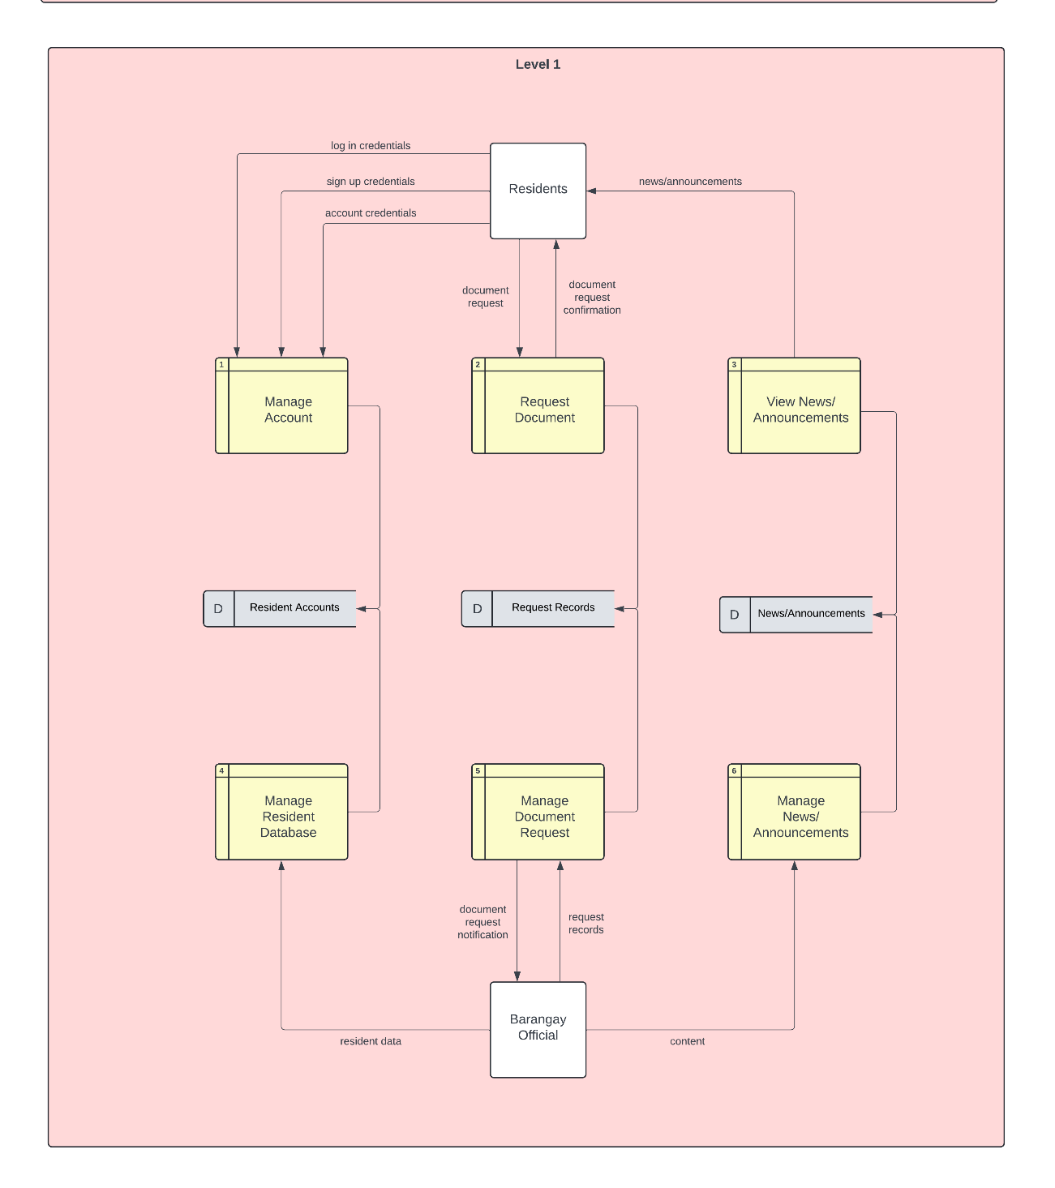

Fig. 11. Data Flow Diagram Level 1

The Level 1 Data Flow Diagram illustrates the core functionalities of the 802-Go platform, designed to streamline communication and service management for Barangay 802. Key users of the system, represented as "Residents," can access various services such as managing their accounts, requesting documents, and viewing news and announcements. Each interaction point is supported by backend processes that ensure secure handling of resident data, request records, and news content.

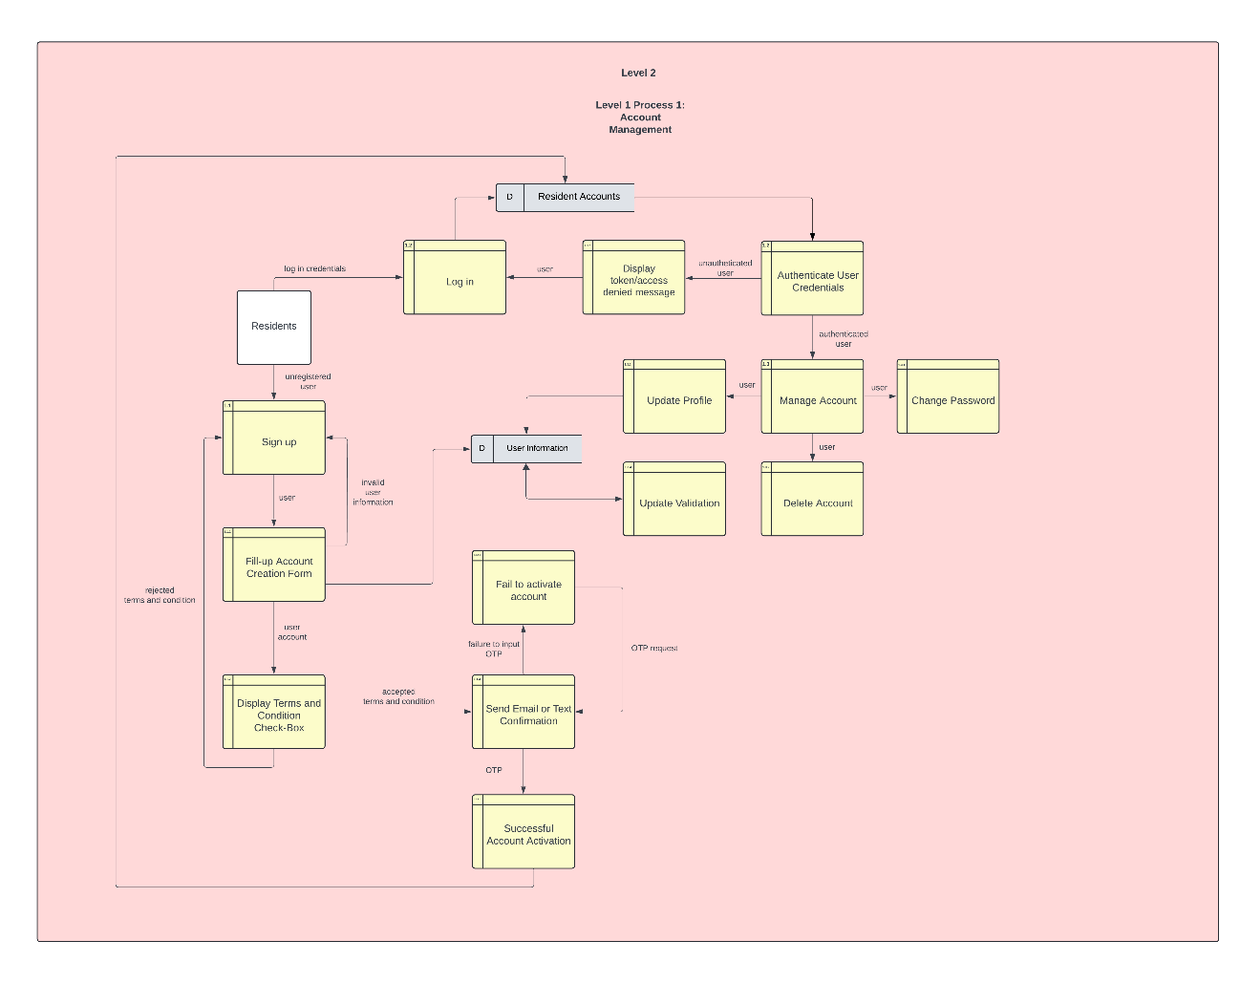

Fig. 12. Data Flow Diagram Level 2 - Level 1 Process 1: Account Management

This process ensures a streamlined and secure account management experience, allowing residents to sign up, log in, and manage their account details within the 802-Go platform.

Fig. 13. Data Flow Diagram Level 2 - Level 1 Process 2: Document Request

This subprocess simplifies document request management, providing residents with timely updates on their applications and ensuring that document issuance is efficient and organized.

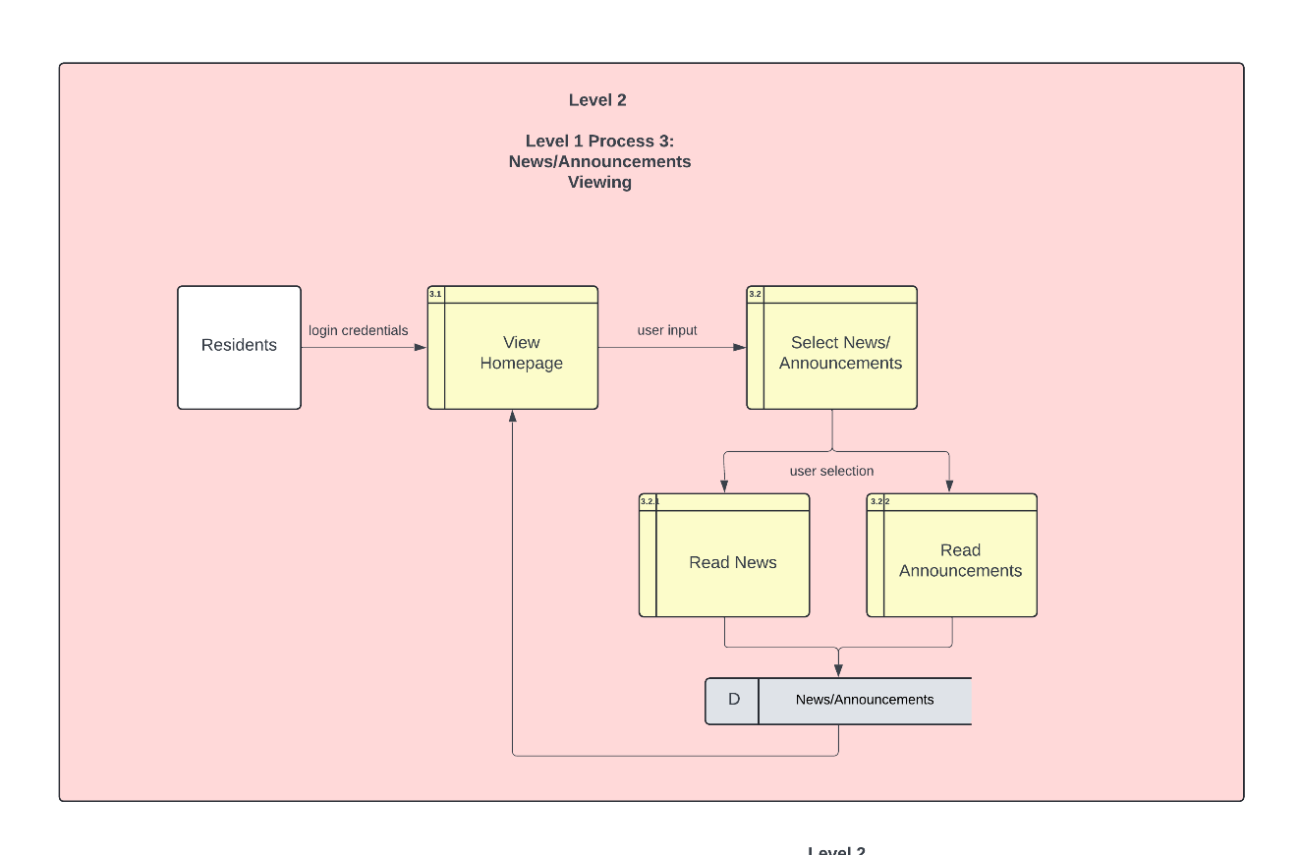

Fig. 14. Data Flow Diagram Level 2 - Level 1 Process 3: News/Announcement Viewing

This process ensures residents have easy access to current and relevant information, fostering a well-informed community through streamlined access to important updates.

Fig. 15. Data Flow Diagram Level 2 - Level 1 Process 4: Resident Database Management

This subprocess provides barangay officials with a secure and organized method of managing resident records, supporting efficient data updates and record-keeping.

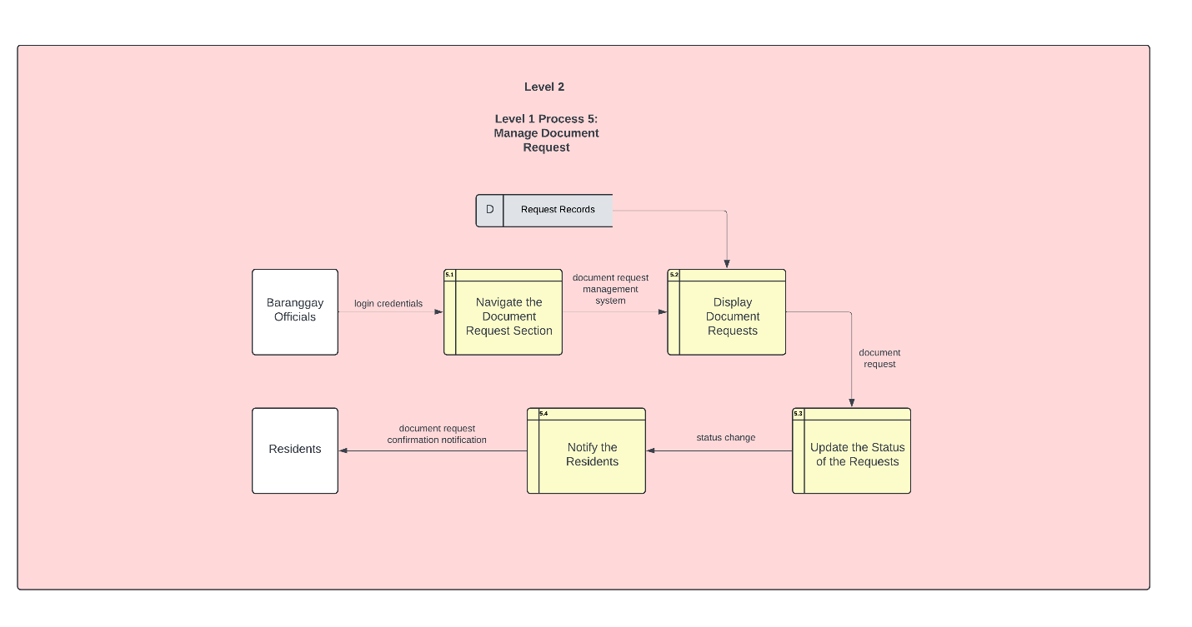

Fig. 16. Data Flow Diagram Level 2 - Level 1 Process 5: Management Document Request

This process enables barangay officials to track and manage document requests efficiently, ensuring that residents receive prompt updates regarding their applications.

Fig. 17. Data Flow Diagram Level 2 - Level 1 Process 5: Management Document Request

This process supports barangay officials in keeping the community updated with important information, contributing to a more engaged and informed community.

Overall, The Level 2 Data Flow Diagram provides a detailed view of the 802-Go platform’s core processes, breaking down each functionality into specific subprocesses that facilitate community engagement, efficient service access, and streamlined communication within Barangay 802. The diagram illustrates how residents and barangay officials interact with the system to manage accounts, submit document requests, view news, and maintain resident data records.

## Test Cases

The Test Cases for Fully Dressed Use Cases are designed to verify that each scenario functions as intended, ensuring reliability and usability for 802-Go users. These test cases address both functional and non-functional requirements, allowing for thorough testing and validation of the system’s core processes. This testing framework will contribute to delivering a robust platform that meets the needs of residents, officials, and local organizations.

Table X. Test Case 1

Table XI. Test Case 2

Table XII. Test Case 3

Table XIII. Test Case 4

Table XIV. Test Case 5

Table XVI. Test Case 6

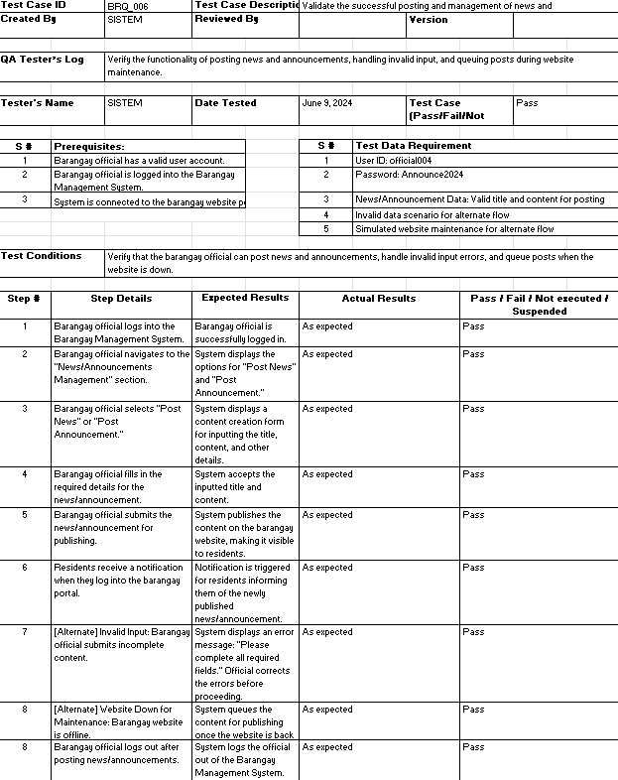

## Activity Diagrams with Swim lanes

Activity Diagrams with Swim lanes provide a visual representation of key workflows within the 802-Go platform, showing interactions between different users, such as barangay officials and residents. By mapping out these processes, the diagrams clarify how various user roles contribute to activities like application submissions, approvals, and community updates. This helps ensure a seamless and intuitive experience for all users.

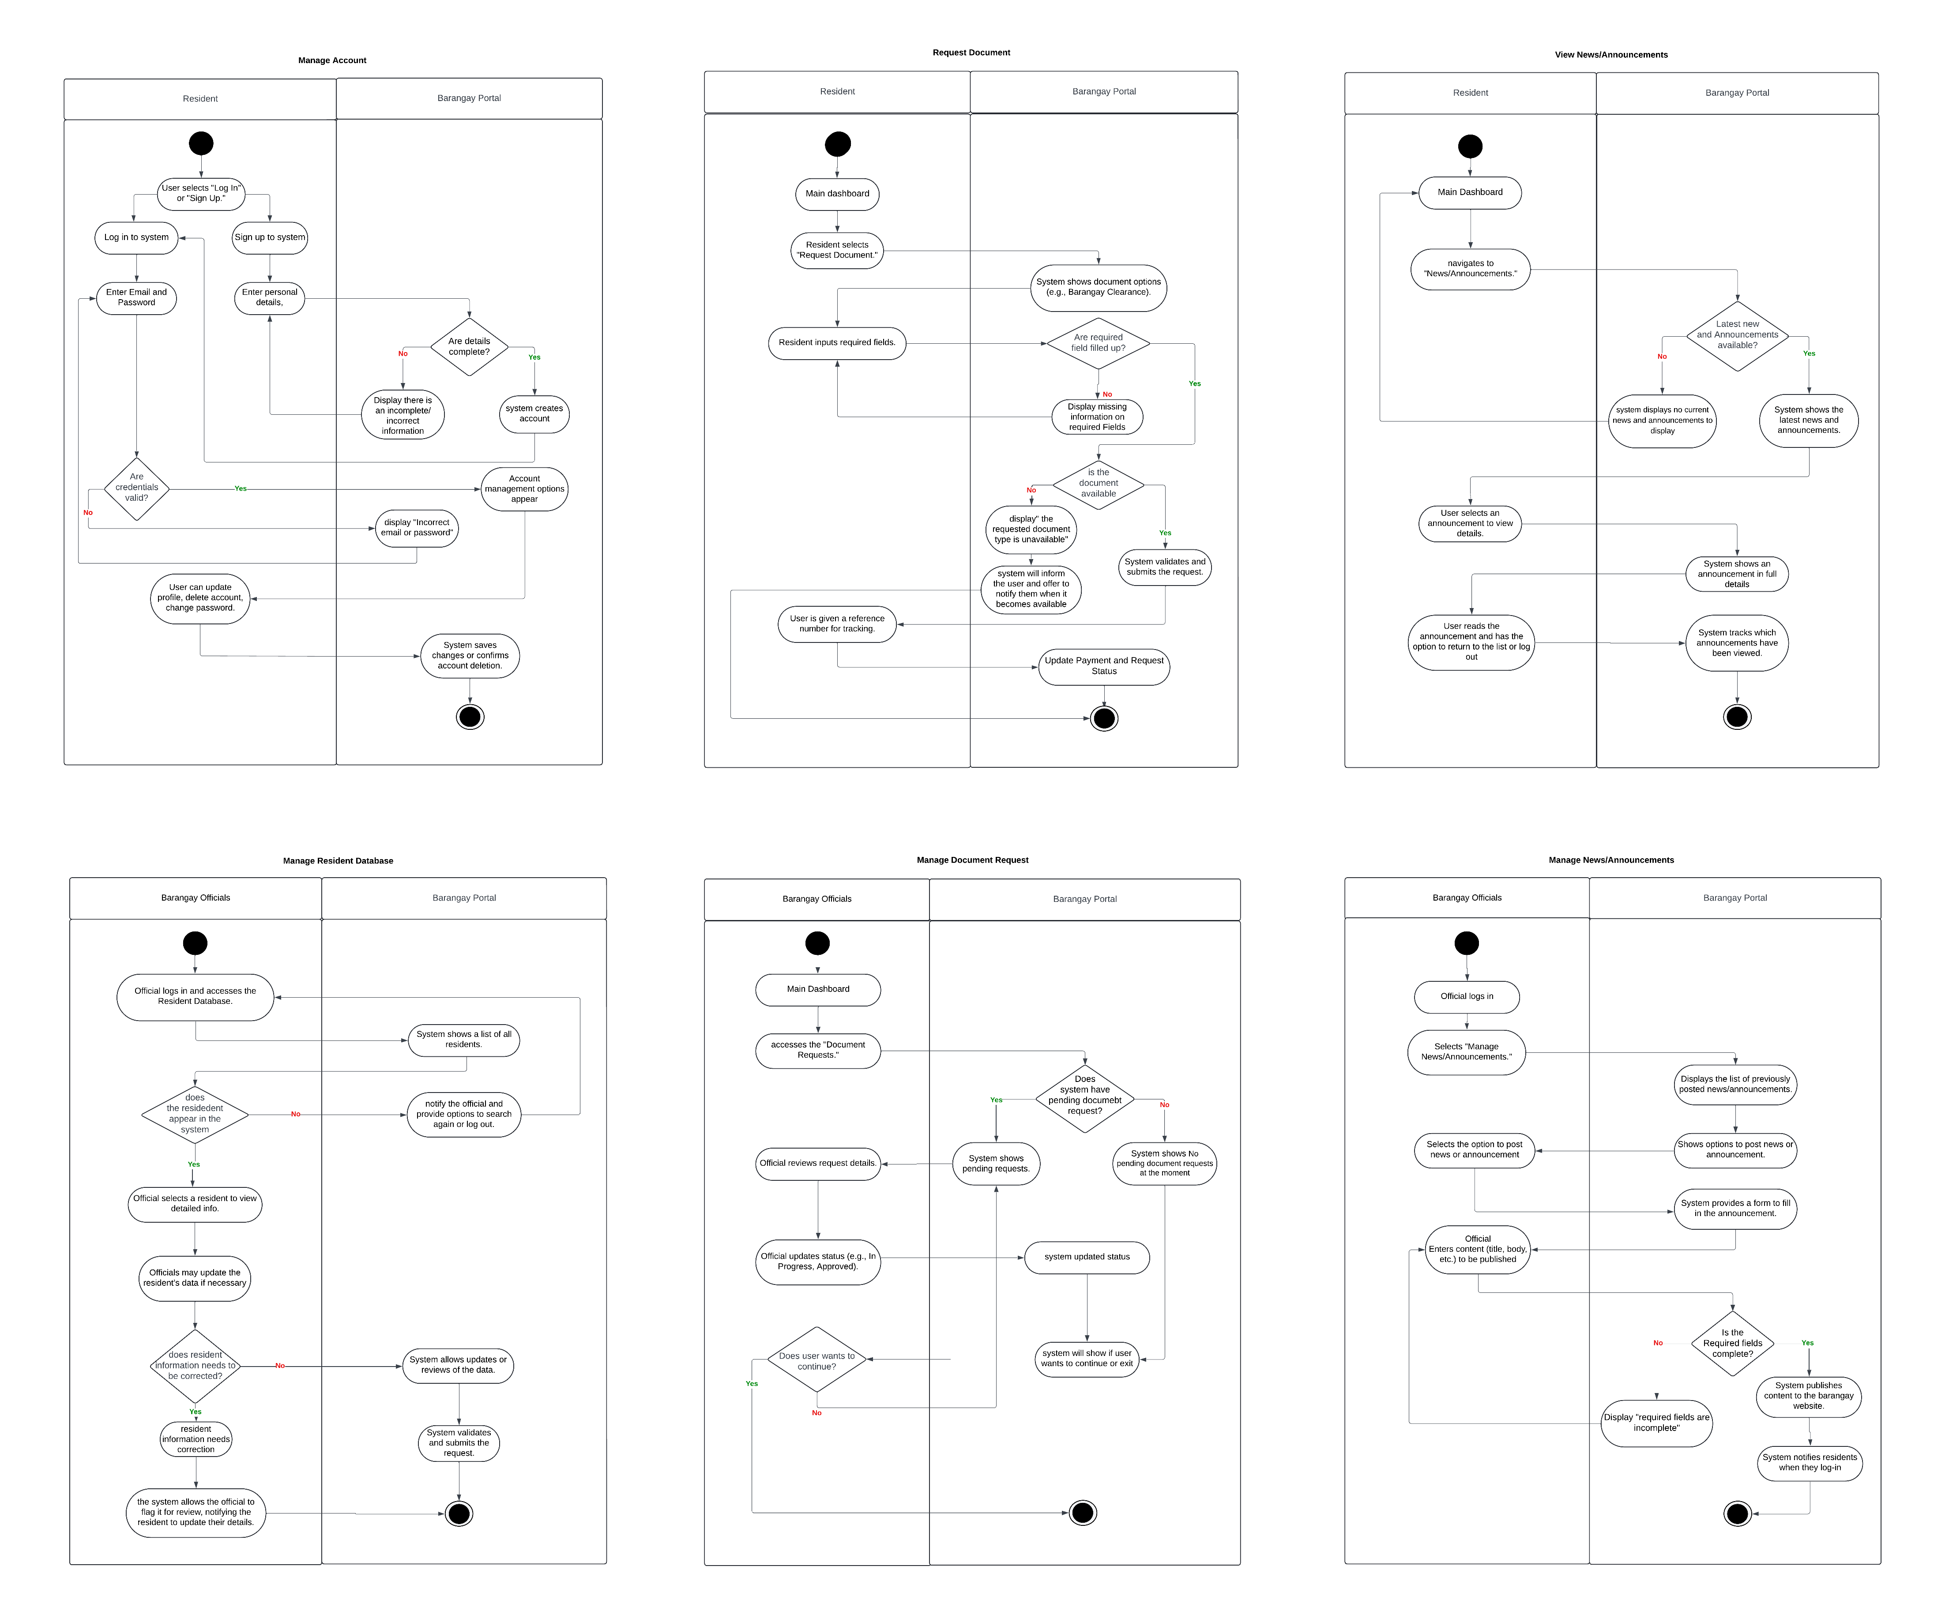

Fig. 18. Activity Diagram – Manage Account



Fig. 19. Activity Diagram – Request Document

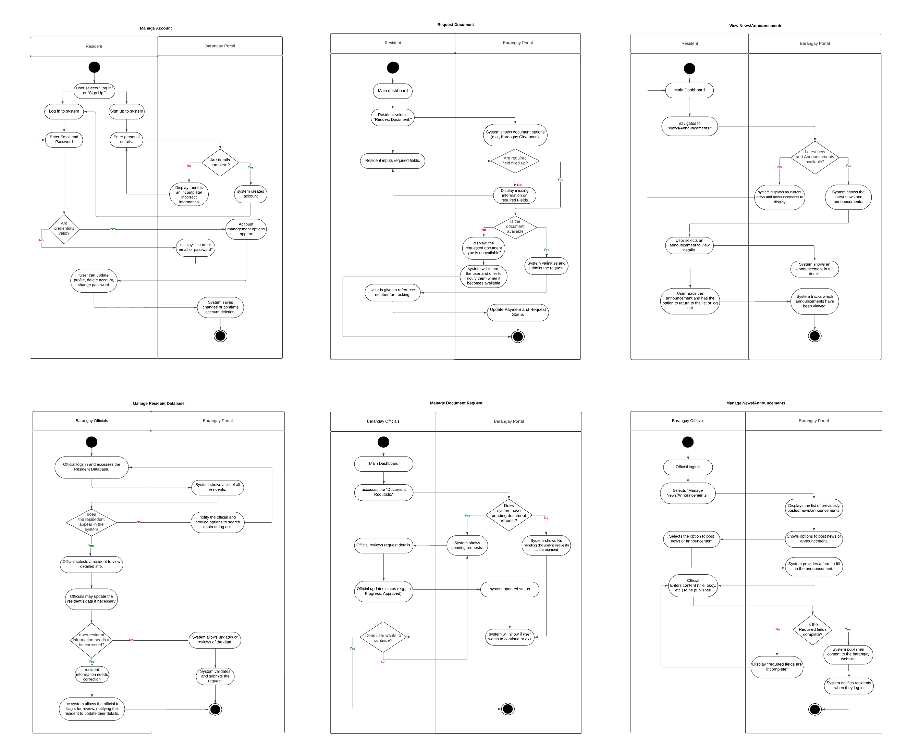

Fig. 20. Activity Diagram – View News/Announcements

Fig. 21. Activity Diagram – Manage Resident Database

Fig. 22. Activity Diagram – Manage Document Request

Fig. 23. Activity Diagram – Manage News/Announcements

## Database Design

The Database Design section includes an Entity-Relationship Diagram (ERD) and Data Dictionary, offering a blueprint of the data architecture for the 802-Go platform. This design will ensure that data is accurately captured, stored, and retrieved, supporting essential functionalities such as record management, application tracking, and reporting. A well-structured database will enhance the system's performance and ensure data integrity for both residents and barangay officials.

Fig. 24. Entity Diagram

## 5.8 User Classes and Characteristics

This table outlines the primary roles within the 802-Go digital portal, detailing the capabilities and responsibilities of each role to ensure clarity in user interactions and system permissions, as well as identifying who they are based on the customer segments of the portal.

Table IV. User Classes and Characteristics

|  |  |
| --- | --- |
| **Roles** | **Description** |
| Administrator | An administrator manages the overall portal operations, including adding new categories, managing security groups, and moderating content. Administrators have the highest level of access and control within the portal. They are responsible for ensuring the site runs smoothly, securely, and according to community guidelines. Administrators are typically barangay officials or designated staff members responsible for overseeing the digital portal. |
| Member | A member is a registered user who has more privileges than a visitor. Members can update their personal information, change passwords, and share content to social networks. They also have the ability to customize their email preferences to manage notifications. Members are usually residents of the barangay who actively participate in community activities and need regular updates and communication with barangay officials. |
| Visitor | A visitor is an unregistered user or someone with basic access. Visitors can view content, create an account, log in, add comments, suggest improvements, and contact administrators. They can follow updates from the barangay and view member profiles to understand community involvement. Visitors include new residents, potential members, and the general public who are interested in the barangay's activities and services but do not yet have a registered account. |

## Initial Cloud Hosted Prototype

For the initial development phase of the 802-Go Barangay Management Portal, the team utilized a Laravel Docker template to lay the groundwork for our cloud-hosted prototype. This approach allowed us to streamline our development environment setup and quickly launch the foundational structure of the portal, ensuring consistency and scalability across environments.

Our primary focus during this phase was on crafting a functional and interactive front-end experience. By prioritizing front-end development, the team aimed to create a responsive user interface that allows users to navigate and interact with the portal intuitively. Even at this early stage, the portal's interface is fully interactive, enabling users to perform core functionalities and get a practical feel of the system's capabilities.

The Laravel Docker template has not only provided a solid base for our development workflow but has also made it easy to manage dependencies and scale as the team move forward with further back-end integrations and data-driven features. This initial prototype sets the stage for a robust Barangay Management Portal that will evolve with more advanced features in subsequent development phases.

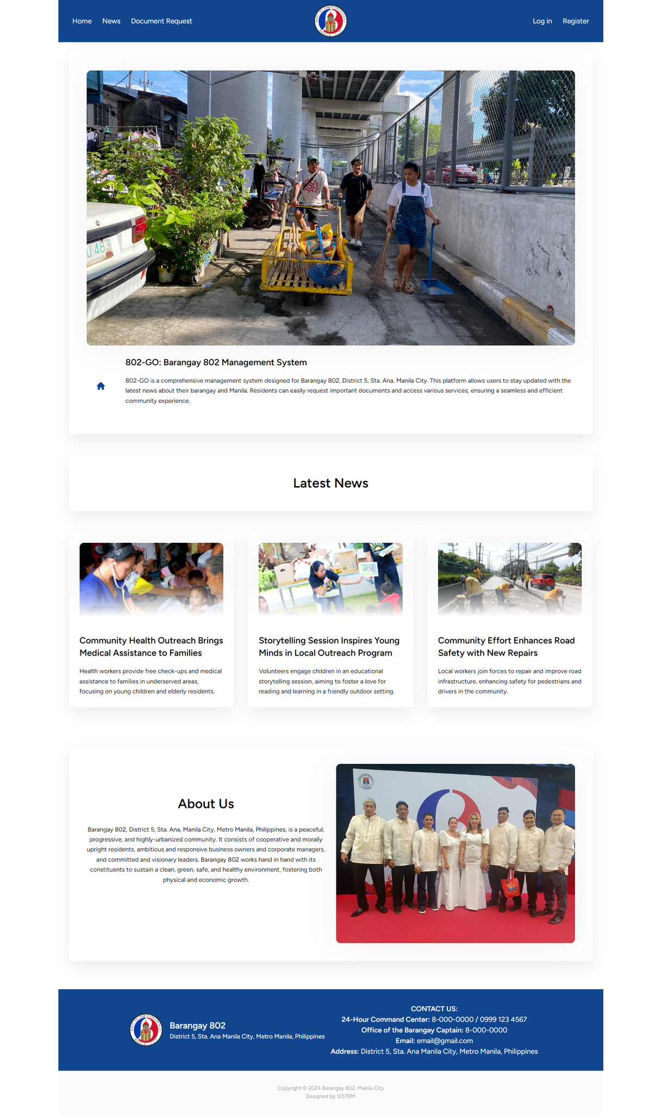

Fig. 25. Home Page Prototype

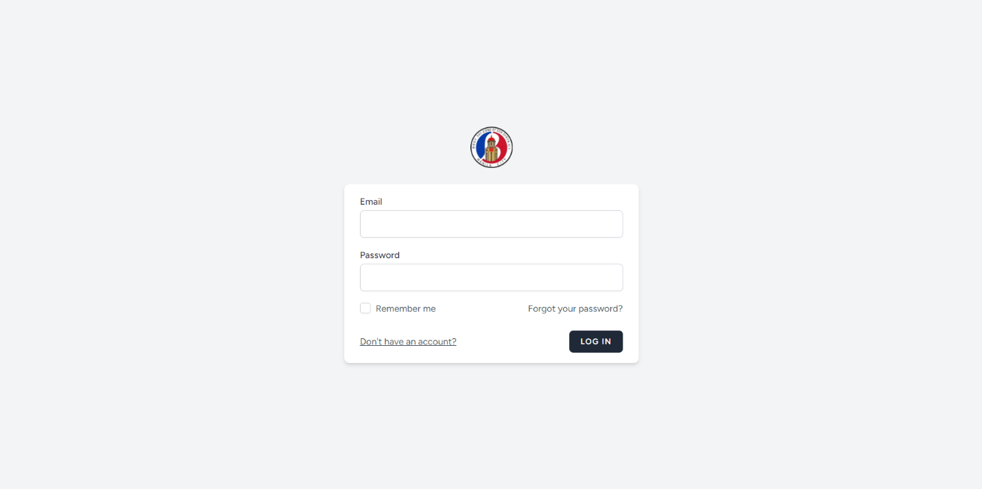

Fig. 26. Log In Page Prototype

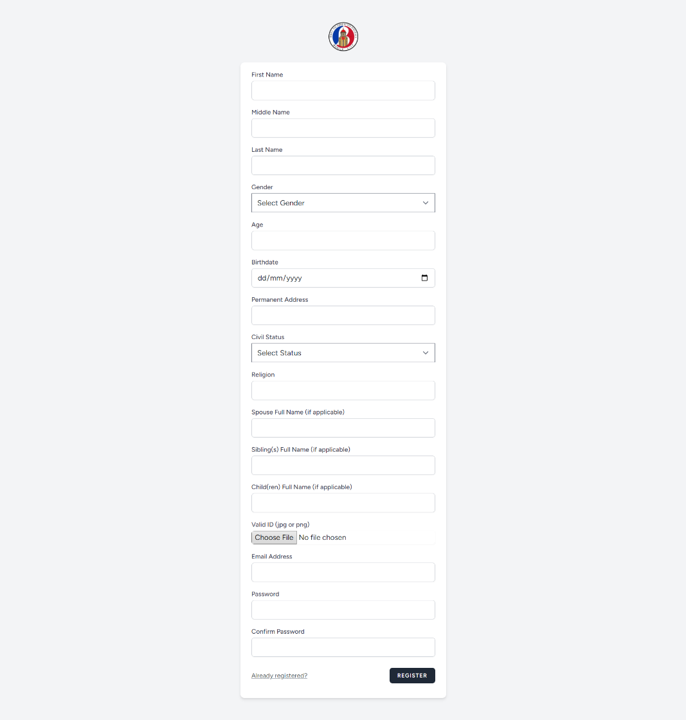

Fig. 27. Register Page Prototype

## 5.10 Updates of Contents in Project GitHub Repository

To ensure transparency and facilitate collaboration, regular updates are made to the project's GitHub repository. These updates include the latest code changes, documentation revisions, and other essential resources, enabling all team members and stakeholders to stay informed of the project's progress. By maintaining an organized and up-to-date repository, we support efficient version control and provide a centralized source of truth for the 802-Go project.

After the initial deployment of the Laravel Docker Template, the team configured the front-end side of the website to align the 802-Go Project.

Fig. 28. GitHub Repository Commits

## 5.11 Prototype

**Technology Stack**

The 802-Go project leverages a range of modern tools and technologies to develop, host, and maintain a robust community engagement platform. Below is an overview of the primary components of our technology stack:

**Version Control and Collaboration:**

* + **GitHub Repository:** The project codebase is hosted on GitHub, allowing for streamlined version control, collaborative development, and easy access to the latest updates. GitHub's pull request and issue tracking features enable efficient project management and team communication.
  + **GitHub Codespaces:** Codespaces provides an integrated development environment (IDE) in the cloud, allowing developers to work on the project from any location without needing to configure a local development setup. This environment supports our Laravel and Docker configurations, making development consistent and scalable.

**Development Frameworks and Tools:**

* + **Laravel Docker Template:** Laravel, a popular PHP framework, is containerized using Docker, allowing for consistent, isolated environments that ensure the application behaves the same across all development and production setups. The Dockerized setup streamlines dependency management and simplifies deployment.

**Languages and Front-End Technologies:**

* + **PHP:** The back-end of the 802-Go platform is developed in PHP, leveraging Laravel’s features for a clean, efficient, and secure back-end architecture.
  + **HTML & CSS:** HTML provides the structure of the portal’s front-end, while CSS is used to style the interface, creating a visually appealing and user-friendly design.
  + **JavaScript:** JavaScript enhances interactivity on the platform, enabling dynamic content updates and improving the user experience.

This technology stack provides a flexible, scalable foundation for developing and deploying the 802-Go platform, facilitating a seamless development workflow and ensuring a smooth transition to production. Each component plays a crucial role in delivering a reliable, interactive experience for the community.

**GitHub Project Repository**

Linked below is the GitHub project repository used by the team, which contains the source code, documentation, and version history for the 802-Go project. This repository is continuously updated to reflect the latest developments and enhancements, providing a collaborative platform for the team and ensuring transparency for stakeholders.

[**APC-SoCIT/APC-2024-2025-T1-07-802-GO-Barangay-Management-System**](https://github.com/APC-SoCIT/APC-2024-2025-T1-07-802-GO-Barangay-Management-System)

# VI. Conclusion

In conclusion, the 802-Go project represents a critical step toward modernizing the communication and service delivery systems in Barangay 802, Santa Ana, Manila. By establishing a centralized digital platform, we aim to enhance community engagement, streamline the application process for permits and licenses, and encourage greater resident involvement through accessible, interactive tools. Supported by the Barangay Council and Sangguniang Kabataan (SK), 802-Go is designed to benefit residents, local businesses, community organizations, and barangay officials alike, offering features such as online applications and an integrated information system.

Transitioning to digital records and a user-friendly portal, along with providing essential technology training, underscores the project’s commitment to creating a more efficient, transparent, and inclusive community experience. Expected outcomes include more accurate record-keeping, modernized communication methods, simplified access to services, better resource management, and overall increased satisfaction among residents. The 802-Go initiative will serve as a model for building a well-informed, digitally-engaged community and offers valuable learning opportunities in digital transformation and community engagement.

As we move forward, finalizing project plans, and initiating the next phases of development are immediate priorities. Ongoing support from key stakeholders—including the Barangay Council, SK, local businesses, community organizations, and residents—will be crucial for the platform’s long-term success. Regular updates and open feedback channels will ensure the platform evolves to effectively meet the community’s needs, delivering on its mission to transform Barangay 802 into a modern, connected, and engaged community.

# References

[1] Gallera, J., Salvador, A. (2023). Assessment of Digital Information Systems for Local Barangays. International Journal of Advanced Engineering and Science, Volume 8, Issue 2, pp. 112-115, 2023. <https://irjaes.com/wp-content/uploads/2023/04/IRJAES-V8N2P171Y23.pdf>

[2] Barangay Management Information System (BAMIS). <https://www.barangayinfosys.com>

[3] Labanan, R., Lacasandile, A. (2020). Development of an Information-Based Dashboard: Barangay Resident Information System and Services (BRISS) for Decision Support towards e-Governance. <https://www.scribd.com/document/541236542/ICSET-2020-BIPS>

[4] Bringula, R., De La Serna, D.J., Napolis, J., Olivia, F., Vale, M.A. (2022). E-Barangay: A Framework for a Web-Based System for Local Communities and Its Usability. International Journal of Electronic Government Research, Volume 18, Issue 1. <https://doi.org/10.4018/IJEGR.288071>

[5] Fang, Z. (2002). E-Government in Digital Era: Concept, Practice, and Development. National Institute of Development Administration (NIDA). <https://egov.ufsc.br/portal/sites/default/files/e-government_in_digital_era.pdf>

[6] Bringula, R., De La Serna, D.J., Napolis, J., Olivia, F., Vale, M.A. (2019). Towards the Development of E-barangay Mobile Application. Proceedings of the 10th International Conference on E-Education, E-Business, E-Management and E-Learning - IC4E ’19. <https://doi.org/10.1145/3306500.3313979>

# Appendices

## Appendix A: Project Vision

In response to the pressing needs of residents, businesses, community organizations, and barangay officials of Barangay 802 in Santa Ana, Manila City, who struggle with outdated communication methods, inefficient service access, and low community engagement, the Barangay Portal emerges as a transformative solution.

Table V. Project Vision

|  |  |
| --- | --- |
| **For** | The Barangay officials, residents, businesses, and community organizations in Barangay 802 of Santa Ana, Manila City. |
| **Who** | Encounter challenges in providing and accessing services efficiently, contend with outdated communication methods, and struggle with limited resident engagement and participation. |
| **The** | 802-Go is a centralized digital platform. |
| **That** | Enhances service access and delivery, streamlines communication, and fosters community engagement. |
| **Unlike** | Conventional Barangay Systems. |
| **Our product** | Provides a user-friendly, one-stop website that empowers residents, supports local businesses, and facilitates efficient governance through modern technology. |

## Appendix B: Schedule

The 802-Go project is structured with a detailed schedule to ensure timely and efficient development. This timeline outlines key phases and activities necessary to achieve the project goals. Each phase involves specific tasks and milestones to maintain project momentum and ensure alignment with stakeholder expectations.

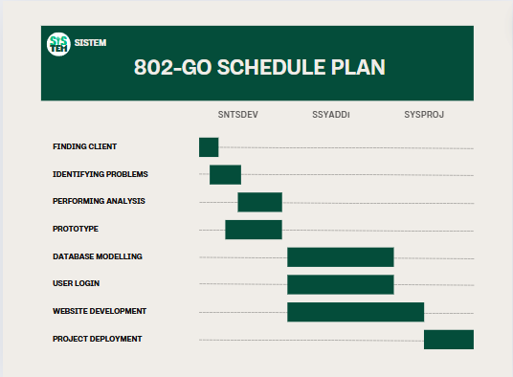

Fig. 29. 802-Go Schedule Plan

# Appendix C: Release Plan

The release plan for the 802-Go project is organized into three phases, each building upon the previous work to achieve a fully functional, user-friendly platform for Barangay 802. Each release focuses on specific deliverables that contribute to the overall functionality, user experience, and deployment of the platform.

**Release 1**

Establish the foundation of the project with thorough documentation and a high-fidelity prototype to guide development.

* **Project Documentation:** This phase begins with detailed documentation covering project requirements, objectives, scope, and design specifications. The documentation ensures that all stakeholders have a clear understanding of the project’s goals and the path forward. It serves as a reference for the entire development process, aligning the project team and stakeholders.
* **High-Fidelity Prototype:** A high-fidelity prototype will be developed to visualize the user interface and interactions within the platform. This prototype aims to resemble the final product closely, including visual design, layout, and key functionalities. It will be used for initial testing, feedback collection, and stakeholder approval before full-scale development begins. The prototype provides a tangible reference for developers, ensuring alignment with the intended user experience.

**Release 2**

Lay down the technical infrastructure and implement core functionalities to allow basic user interaction with the system.

* **Database Modeling:** In this release, the database structure is designed and implemented. This involves defining the data tables, relationships, and schemas needed to store and manage resident information, document requests, announcements, and other essential data. A well-structured database is crucial for data integrity, security, and efficient retrieval.
* **Web Application Development:** The primary features of the 802-Go portal are built in this phase, focusing on the interface that residents and officials will use to interact with the system. This includes designing responsive layouts and implementing front-end and back-end functionalities to create a functional, accessible web portal.
* **User Login:** This critical feature provides a secure login system to authenticate residents and officials. User login functionality ensures that only authorized users can access their respective areas in the platform. It includes mechanisms such as password encryption, login validation, and possibly two-factor authentication for enhanced security.

**Release 3**

Enhance system functionality with reporting capabilities and finalize deployment for public access.

* **Automated Web Reports:** In this phase, the system will be equipped to generate automated web-based reports, providing real-time insights into metrics like document request statuses, user engagement, and system usage. These reports will aid barangay officials in decision-making, resource management, and tracking project success.
* **Project Deployment:** The final phase involves deploying the platform to a live environment, making it accessible to all users. This step includes configuring servers, ensuring security measures are in place, and performing final quality assurance testing. Upon deployment, the system will be fully operational, enabling residents, officials, and other stakeholders to interact with the platform as intended.

## Appendix D: Product Roadmap

Table VI. Product Roadmap

|  |  |  |
| --- | --- | --- |
| **SNTSDEV** | **SSYADD1** | **SCSPROJ** |
| **Finding client**   * Looking for possible clients * Proposing initial idea * Research   **Identifying Problems**   * User Interview * Client Interview * Proposal of ideas   **Performing Analysis**   * Concept analysis * SWOT Analysis * Fishbone Diagram * Feasibility   **Prototype**   * Identifying features * Low fidelity prototype * High fidelity prototype | **Database Modelling**   * Database schema based on requirements * Defined entity relationships * Tables for user data, content, and configurations   **Website Development**   * UI for administrators, members, and visitors * Develop frontend and Implement backend logic for data handling * Ensure responsive design across devices   **User Login**   * Login interfaces for different user roles * Authentication using secure protocols * Implement password hashing and encryption * Session management and role permissions | **Automated web reports**   * Website usage reports   **Project Deployment**   * Website testing * Administrator training |

## Appendix E: Teams Meetings

Table VII. Minutes of the Meetings

|  |  |  |  |
| --- | --- | --- | --- |
| Date | Participants | Title | Agenda |
| August 12, 2024 | * Joana Grace Garcia * Allan Miguel Moldez * Hazel Ann Mones * Jhon Iberson Marinas | 1st Team Meeting | * Project Request Adviser Form * PrepareUse Case Diagram/Product Backlog * Revise Sharepoint * Fill-up Kanban Board |
| August 12, 2024 | * Mr. Ryan Perez (Adviser) * Jose Enrique Nunez | 1st Adviser Meeting | * Propose Project Adviser Form Request |
| August 15, 2024 | * Joana Grace Garcia * Allan Miguel Moldez * Hazel Ann Mones * Jhon Iberson Marinas * Jose Enrique Nunez | 2nd Team Meeting | * Assigning DFD Levels to each member * Fill-up Kanban Board |
| August 19, 2024 | * Joana Grace Garcia * Allan Miguel Moldez * Hazel Ann Mones * Jhon Iberson Marinas * Jose Enrique Nunez | 3rd Team Meeting | * Update Use Case Diagram * Start Fully Dressed Use Case |
| September 24, 2024 | * Mr. Ryan Perez (Adviser) * Joana Grace Garcia * Allan Miguel Moldez * Hazel Ann Mones * Jhon Iberson Marinas * Jose Enrique Nunez | 2nd Adviser Meeting | * Check Diagrams for Revisions * Dissemination of parts of the Presentation * Prepare for the possible questions * Suggestions and Advise of the Adviser |
| October 1, 2024 | * Joana Grace Garcia * Allan Miguel Moldez * Hazel Ann Mones * Jhon Iberson Marinas * Jose Enrique Nunez | 5th Team Meeting | * Comment Matrix * Revision of Diagrams Based on the Comment Matrix * Assigning of ERD * Finalization of Technical Requirements of the Project |
| October 11, 2024 | * Mr. Ryan Perez (Adviser) * Joana Grace Garcia * Allan Miguel Moldez * Hazel Ann Mones * Jhon Iberson Marinas * Jose Enrique Nunez | 3rd Adviser Meeting | * Discuss Midterm Presentation * Discuss Revised Diagrams * Suggestions and Advise of the Adviser |
| October 15, 2024 | * Mr. Ryan Perez (Adviser) * Joana Grace Garcia * Allan Miguel Moldez * Hazel Ann Mones * Jhon Iberson Marinas * Jose Enrique Nunez | 4th Adviser Meeting | * Finalization of Diagrams * Start working on Ground Repository * Finalize Paper Documentation * Finalize Prototype * Update SharePoint |